CONVERSATIONAL REQUIREMENT ELICITATION, RETRIEVAL-GROUNDED DOMAIN ENRICHMENT AND CHECKPOINTED ORCHESTRATION IN THE AUTOFORGE MULTI-AGENT PIPELINE
Individual Thesis
Santhuka D.N.M.D.
IT22098078
Component: Requirement Generation, Domain Enrichment and Checkpointed Orchestration
Group ID: R26-SE-033
Thesis submitted in partial fulfilment of the requirements for the
Bachelor of Science (Honours) in Information Technology
Specialising in Software Engineering
Department of Software Engineering
Sri Lanka Institute of Information Technology
Sri Lanka
October 2026

DECLARATION AND SUPERVISOR CERTIFICATION
Candidate declaration. I declare that this thesis is my own work and does not incorporate, without acknowledgement, material previously submitted for a degree or diploma at any university or institute of higher learning. To the best of my knowledge, it contains no material previously published or written by another person except where acknowledgement is made in the text. I grant the Sri Lanka Institute of Information Technology the non-exclusive right to reproduce and distribute this thesis, in whole or in part, in print, electronic, or other media, while retaining the right to use the content in future work.
Academic integrity and AI disclosure. I have disclosed all use of generative AI and other automated tools in accordance with the module policy. I remain responsible for the accuracy, originality, citations, code, data, analyses, and conclusions in this thesis.
Student name | Student ID | Signature | Date
Santhuka D.N.M.D. | IT22098078
Supervisor certification. The above candidate carried out this research for the bachelor's degree thesis under my supervision.
Role and name | Signature | Date
Supervisor: Nuwan Kodagoda
Co-supervisor: Eishan Weerasinghe
Abstract
Multi-agent systems that build software with large language models usually start from a requirement the model has to guess at, and they review that requirement, if at all, through agent dialogue. A wrong early assumption then travels into the design and the code. This thesis covers the first two stages of AutoForge, a seven-agent pipeline for e-commerce web development, and the orchestration layer that joins all seven. The Requirement Agent fills gaps through a short conversation, asking at most three questions per turn, and a deterministic quality gate blocks confirmation while key fields are vague or assumed. The SRS is then generated through a single schema-constrained call, with a JSON repair step and a deterministic fallback. The Domain Agent retrieves domain knowledge from a ChromaDB index and asks the model only for a small, cited enrichment plan, which Python validates and merges, so the model never retypes the specification. A LangGraph state graph checkpointed to MongoDB pauses at every human gate and resumes after any delay or restart. Following a design-science approach, I evaluated the work within the team's three-feature case study. With retrieval enabled, useful domain requirements rose from 8 to 14, missing requirements fell from 7 to 2 and human revisions halved. All seven controlled interruptions resumed at the correct stage with earlier approvals intact. Human review caught a missing pair of Admin and Manager user stories before any design existed. A real run on a retail store feature also exposed two weaknesses that only a reviewer caught: an irrelevant guest-checkout constraint pulled in by retrieval, and a citation check that a reviewer's question could satisfy. The results suggest that grounding and gating the earliest stages is a practical way to stop specification errors from reaching code, provided the review step stays meaningful.
Keywords: requirements engineering, retrieval-augmented generation, human-in-the-loop, checkpointed orchestration, multi-agent systems
ACKNOWLEDGEMENTS
I would like to thank my supervisor, Nuwan Kodagoda, and my co-supervisor, Eishan Weerasinghe, for their guidance throughout this project. Their insistence that every claim about the pipeline be backed by a measurement, not a description, changed how I evaluated my own component and is the reason Chapter 6 reports what went wrong as well as what worked.
I am grateful to my teammates, Sansala T.G.B.D., Dissanayake T.C. and Oberathna R.D.T.D. Their agents were the first real consumers of the specifications my component produces, and several of the design changes described in this thesis started as a bug they ran into downstream.
I also thank the academic staff of the Department of Software Engineering at the Sri Lanka Institute of Information Technology, and the panel members at the progress presentations, whose questions helped narrow the scope of this work. Finally, I thank my family and friends for their patience over the many long evenings this project took.
TABLE OF CONTENTS
Declaration and Supervisor Certification i
Abstract ii
Acknowledgements iii
Table of Contents iv
List of Figures vii
List of Tables viii
List of Abbreviations ix
1 INTRODUCTION 1
1.1 Overall Project Context 1
1.2 Individual Component Context 2
1.3 Problem Statement 3
1.4 Research Gap 4
1.5 Aim and Objectives 4
1.6 Research Questions 5
1.7 Scope, Limitations and Assumptions 5
1.8 Individual Contribution 6
1.9 Thesis Structure 7
2 LITERATURE REVIEW AND RELATED WORK 8
2.1 Review Method and Scope 8
2.2 Domain and Theoretical Foundations 8
2.2.1 Requirements specifications as the root of the pipeline 8
2.2.2 Retrieval-augmented generation 9
2.2.3 Traceability 9
2.2.4 Human oversight and durable workflow state 9
2.2.5 Design science 10
2.3 Related Research 10
2.4 Existing Systems, Products and Techniques 11
2.5 Gap Synthesis and Conceptual Framework 12
3 RESEARCH METHODOLOGY 13
3.1 Research Design 13
3.2 Data, Participants and Study Materials 13
3.3 Experimental and Study Procedure 14
3.4 Measures and Evaluation Metrics 15
3.5 Data Analysis 16
3.6 Ethics, Privacy, Security and Responsible AI 16
3.7 Reproducibility and Research Artefacts 17
4 PRODUCT AND SOLUTION DESIGN 18
4.1 Requirements 18
4.2 Component Architecture within the Complete Solution 19
4.3 Design Alternatives and Decisions 20
4.4 Detailed Design 21
4.4.1 Conversational requirement elicitation 21
4.4.2 SRS structure and generation 23
4.4.3 Revision through targeted operations 24
4.4.4 Knowledge ingestion and retrieval 25
4.4.5 Enrichment plan, validation and merge 26
4.4.6 Orchestration as a checkpointed state graph 26
4.4.7 Approval and versioning 28
4.5 Standards and Professional Practice 28
5 IMPLEMENTATION 29
5.1 Development Environment and Technology Stack 29
5.2 Implementation of the Core Modules 29
5.2.1 Requirement Agent 30
5.2.2 Retrieval pipeline 31
5.2.3 Domain Agent 31
5.2.4 Orchestrator and approval service 32
5.2.5 LLM provider service 32
5.3 Integration with the Complete Solution 33
5.4 Testing and Quality Assurance 33
5.5 Deployment and Operation 34
6 RESULTS AND EVALUATION 35
6.1 Component-Level Test Results 35
6.2 Experimental Results 36
6.2.1 Effect of retrieval on completeness (RQ1) 36
6.2.2 Small plan versus full regeneration (RQ2) 37
6.2.3 Checkpoint recovery (RQ3) 37
6.2.4 Human review at the early stages (RQ4) 38
6.3 Stakeholder and User Validation 39
6.4 Worked Example: Retail Store "Add & List Items" 39
6.4.1 The generated SRS 39
6.4.2 The Enhanced SRS and its revisions 40
6.5 Integration and Performance Results 41
6.6 Summary of Findings 42
7 DISCUSSION 43
7.1 Interpretation of the Results 43
7.2 Comparison with Related Work 44
7.3 Implications for Practice 44
7.4 Threats to Validity 45
7.5 Limitations 45
8 COMMERCIALISATION AND SUSTAINABILITY 47
8.1 Value of the Component 47
8.2 Target Users and Market Position 47
8.3 Business Model and Feasibility 48
8.4 Sustainability and Maintenance 48
8.5 Contribution to the Sustainable Development Goals 49
9 CONCLUSION AND FUTURE DIRECTIONS 50
9.1 Conclusion 50
9.2 Achievement of Objectives 50
9.3 Contribution 51
9.4 Future Directions 51
REFERENCES 52
GLOSSARY 54
APPENDICES 56
Appendix A: Supporting Technical Material 56
Appendix B: Disclosure of AI Tool Use 58
LIST OF FIGURES
Figure 1.1 The AutoForge pipeline, showing the seven agents, their outputs, human approval and feedback loops 2
Figure 2.1 Conceptual framework for the requirement, domain and orchestration component 12
Figure 4.1 The component's place in the complete AutoForge architecture 20
Figure 4.2 Requirement elicitation, quality gate and SRS generation 22
Figure 4.3 Domain knowledge ingestion and the enrichment pipeline 25
Figure 4.4 The orchestration state graph with five hard approval gates and two soft gates 27
Figure 6.1 Retrieval ON versus OFF on the same request and model 36
LIST OF TABLES
Table 2.1 Requirement-stage properties of related systems 11
Table 3.1 Domain knowledge base used in the evaluation 14
Table 3.2 Measures used for each research question 15
Table 3.3 Configuration parameters relevant to reproducing the results 17
Table 4.1 Functional requirements of the component 18
Table 4.2 Non-functional requirements of the component 19
Table 4.3 Main design decisions 20
Table 4.4 Sections of the generated SRS 23
Table 5.1 Technology stack used by the component 29
Table 5.2 Main modules of the component 30
Table 5.3 Automated tests for the component 33
Table 6.1 Key behaviours confirmed by automated tests 35
Table 6.2 Retrieval ablation on one controlled request 36
Table 6.3 Observed behaviour of the two Domain Agent designs 37
Table 6.4 Controlled checkpoint-recovery trials 37
Table 6.5 Pipeline with human gates on and off 38
Table 6.6 Composition of the retail store SRS, version 1 39
Table 6.7 Enhanced SRS versions for the retail store feature 40
Table 6.8 Execution performance of the full pipeline 41
Table 6.9 Summary of findings by research question 42
Table 8.1 Alternatives for producing a feature specification 47
Table 9.1 Achievement of the objectives 50
Table A.1 Test files for the component 56
Table A.2 Rules applied by the requirement quality gate 57
Table B.1 Use of generative AI tools 58
LIST OF ABBREVIATIONS
Abbreviation | Description
AC | Acceptance Criterion
AI | Artificial Intelligence
API | Application Programming Interface
BA | Business Analyst
CRUD | Create, Read, Update and Delete
DOCX | Office Open XML Word Document
FR | Functional Requirement
JSON | JavaScript Object Notation
LLM | Large Language Model
NFR | Non-Functional Requirement
PDF | Portable Document Format
QA | Quality Assurance
RAG | Retrieval-Augmented Generation
REST | Representational State Transfer
RQ | Research Question
SDG | Sustainable Development Goal
SDLC | Software Development Life Cycle
SME | Small and Medium-sized Enterprise
SRS | Software Requirements Specification
UI | User Interface
UML | Unified Modeling Language
US | User Story
UX | User Experience
VR | Validation Rule

1 INTRODUCTION

1.1 Overall Project Context
AutoForge is our team's final-year research project. It is a multi-agent system that builds features of an e-commerce web application with large language models (LLMs), but it does so in stages, the way a software team would, rather than jumping from a prompt to finished code. Seven agents take turns: a Requirement Agent writes the Software Requirements Specification (SRS), a Domain Agent enriches it with domain knowledge, an Architecture Agent designs the system, a UI/UX Agent designs the screens, a Coder Agent implements the change, and Security and Quality Assurance (QA) agents check the result. Each agent produces a versioned artefact, and the pipeline pauses so that a person can approve it, reject it or ask for changes before the next agent sees it.
The motivation comes from a simple observation that our research paper opens with. An LLM can already write a working function or a page on request, but a full application depends on a chain of decisions, and tools that generate everything from one prompt leave no specification to check and no way to tell whether a poor result came from a misunderstood requirement or a coding mistake. Multi-agent frameworks such as ChatDev [1] and MetaGPT [2] improve on this by giving agents separate roles, but review still happens through agent conversation or after the run ends. Figure 1.1 shows the AutoForge pipeline as it appears in the paper.
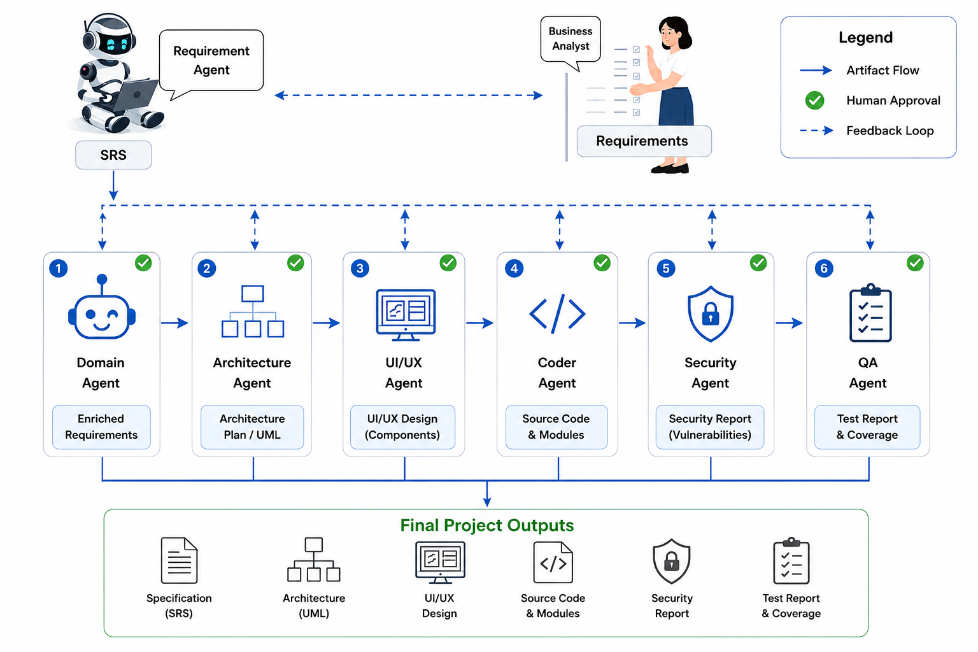
Figure 1.1: The AutoForge pipeline, showing the seven agents, their outputs, human approval and feedback loops
The project was divided into four components, one per team member. My component covers the first two stages of the pipeline, the Requirement Agent and the Domain Agent, together with the orchestration layer that connects all seven agents, pauses them for human decisions and lets the pipeline survive interruptions. The other three components cover architecture and UI/UX design, code generation, and security and quality assurance. The team's common report describes the integrated system; this thesis describes my component in detail.

1.2 Individual Component Context
The first two stages of a development pipeline matter more than their size suggests. Every later agent builds on the specification: the Architecture Agent derives its plan and diagrams from it, the UI/UX Agent decides which screens to draw from it, and the Coder Agent decides what to implement from it. A gap or a wrong assumption at this point does not stay small. In e-commerce, where features touch accounts, stock levels, orders and payment data, a requirement that is cheap to fix while it is still a sentence in a specification becomes expensive once database models, endpoints and pages have been built around it.
My component therefore has three jobs. The first is to turn a rough feature idea into a specification that is complete enough for the downstream agents to use without guessing. The second is to check that specification against domain knowledge, so that conventions a general-purpose model might miss, such as how inventory or order states are usually handled, are added and clearly marked. The third is to make the whole pipeline controllable: every stage has to be able to wait for a person, for minutes or days, without losing its place, and to continue correctly once a decision arrives.
These three jobs are connected. A specification is only worth reviewing if the review can actually stop the pipeline, and a pause is only practical if the system can be restarted while it waits. That is why I treat the early agents and the orchestration layer as one component rather than three separate pieces.

1.3 Problem Statement
When an LLM-based system writes a requirements specification for a new feature, it usually works from whatever the user typed and from the model's own general knowledge. Three problems follow. First, the input is often incomplete, and the model fills the gaps silently, so the specification looks complete while resting on assumptions nobody agreed to. Second, the model's general knowledge may not include the conventions of the target domain, and when it does try to add them, there is no way to tell which additions are grounded in a real source and which were invented. Third, asking a model to regenerate a whole document to make a small change is unreliable: during our development, three different locally hosted models dropped required sections, omitted keys or produced truncated output when asked to retype the full specification.
On top of this, existing multi-agent frameworks do not give a person a durable point of control. Review happens through agent dialogue or after the run, and an interrupted run is generally lost. The problem this thesis addresses is therefore: how can the requirement and domain stages of an LLM-based development pipeline produce a specification that is complete, grounded in cited domain knowledge, safely revisable and approved by a person, within a pipeline that can pause indefinitely and resume correctly after interruption?

1.4 Research Gap
The literature reviewed in Chapter 2 points to a gap with four parts. Role-based systems such as MetaGPT [2] produce an SRS-like document, but they build it from the model's parametric knowledge without retrieving outside domain knowledge in the sense Lewis et al. [3] established, and Hemmat et al. [4] describe domain grounding of LLMs in requirements engineering as an under-explored direction. None of the systems we reviewed treats the specification as an independently versioned artefact with its own accept, reject or revise decision, even though Takerngsaksiri et al. [5] found that engineers value oversight at the planning stage as much as at the code stage. Traceability research [6], [7] shows that most solutions cover one narrow link rather than a chain from requirement to code, which needs stable identifiers from the very first artefact. Finally, none of these systems reports a pipeline state that survives a restart, which is what makes a human gate practical.
What is missing, then, is a requirement stage that asks before it assumes, a domain stage that can only add what it can cite, a revision mechanism that changes exactly what was asked and nothing else, and an orchestration layer that holds the whole pipeline still while a person decides.

1.5 Aim and Objectives
The aim of this work is to design, implement and evaluate the requirement and domain stages of AutoForge, and the checkpointed orchestration layer that controls the full pipeline, so that the specification every later agent depends on is complete, grounded, traceable and human-approved.
To reach this aim I set four objectives:
1. O1: Build a Requirement Agent that fills gaps through a short conversation, refuses to confirm a vague specification without an explicit override, and produces a schema-valid SRS with stable identifiers and traceability.
2. O2: Build a retrieval pipeline and a Domain Agent that enrich the approved SRS only with knowledge they can cite, without asking the model to regenerate the specification.
3. O3: Build an orchestration layer that pauses the pipeline at human approval gates, records each decision, and resumes from the exact paused point after any delay or restart.
4. O4: Evaluate the effect of retrieval on specification completeness, the reliability of checkpoint recovery, and the value of human review at the early stages.

1.6 Research Questions
The objectives lead to four research questions. They are narrower versions of the pipeline-level questions in our research paper, focused on the part of the system I built.
1. RQ1: Does retrieval-grounded enrichment produce a more complete specification than generation without retrieval?
2. RQ2: Does a "small plan, deterministic merge" design preserve the specification's structure and identifiers better than asking the model to regenerate the whole document?
3. RQ3: Can a checkpointed state graph hold the pipeline at a human gate and resume it correctly after an interruption?
4. RQ4: Does human review at the requirement and domain stages catch problems before they reach design and code?

1.7 Scope, Limitations and Assumptions
The work covers the requirement and domain stages for individual features of e-commerce web applications, and the orchestration of all seven stages. The domain knowledge base used in the evaluation is an e-commerce knowledge base of five short documents covering catalogue and inventory, carts and checkout, order life cycles, payments and accounts. The design itself is domain-independent: neither the validator nor the merge logic contains e-commerce rules, so another knowledge base could be swapped in.
The main limitations follow from the evaluation scale. Retrieval was compared with and without enrichment on one controlled request, checkpoint recovery was tested with seven controlled interruptions, and the case study covers three features. These are enough to show that the mechanisms work and to measure their effect, but not to give general rates with statistical confidence. The knowledge base is also small, which limits what retrieval can contribute and, as Chapter 6 shows, makes irrelevant matches more likely.
I assume that a person with enough knowledge of the feature is available to answer the requirement questions and review each artefact, though not necessarily straight away, since the pipeline is designed to wait. I also assume that the machine running AutoForge can host the default model through Ollama and reach a MongoDB database for artefacts and checkpoints.

1.8 Individual Contribution
My contributions to the project, all of which are reflected in the shared repository's history, are:
• the Requirement Agent, including the conversational gap-filling loop, the deterministic quality gate, SRS generation with a repair-and-fallback ladder, a completeness backstop, and revision through targeted operations;
• the domain knowledge pipeline (document loading, chunking, embedding and ChromaDB storage) and the Domain Agent's plan, validate and merge design;
• the LangGraph orchestration layer with its MongoDB checkpointer, and the approval service that turns a person's decision into a resumed pipeline;
• the per-agent LLM provider service that lets each agent run on a different model or provider; and
• the automated tests for these modules, and my share of the team's evaluation and research paper.

1.9 Thesis Structure
Chapter 2 reviews the literature and existing systems and builds a conceptual framework. Chapter 3 describes the research method. Chapter 4 presents the design of the component and the decisions behind it, and Chapter 5 covers implementation, integration with the other components, and testing. Chapter 6 reports the results, including a real run on a retail store feature, and Chapter 7 discusses what they mean. Chapter 8 considers commercialisation and sustainability, and Chapter 9 concludes. The appendices contain the test catalogue, the knowledge base inventory and the disclosure of AI tool use.

2 LITERATURE REVIEW AND RELATED WORK

2.1 Review Method and Scope
I started from two broad surveys, Hou et al.'s systematic review of LLMs for software engineering [8] and He, Treude and Lo's review of LLM-based multi-agent systems for software engineering [9], and followed their references to the systems most relevant to AutoForge. From there the review narrowed to four themes that bear directly on my component: multi-agent systems that produce specifications, human oversight of agents, retrieval-augmented generation, and requirements traceability. Work on testing and security with LLMs [10], [11] and on coding agents [12], [13] was included as context, since the specification my component produces is what those later stages build on.
The review shares its sources with the team's research paper. I included work that describes a system or method concretely enough to compare with ours, and surveys that summarise a research area. I did not attempt a full systematic review; the aim was to locate the gap precisely enough to design against it.

2.2 Domain and Theoretical Foundations

2.2.1 Requirements specifications as the root of the pipeline
A requirements specification records what a system must do and under what conditions, in a form that both people and later development stages can use. In AutoForge the SRS is not just a document for reading; it is the input every later agent consumes. That places two demands on it that a human-written specification does not always meet. It has to be structured, so that an agent can read particular sections reliably, and each requirement needs a stable identifier, so that later artefacts can point back to it. Hemmat et al. [4], reviewing research on LLMs in requirements engineering, note that work so far has concentrated on generating and classifying requirements, with less attention to grounding them in domain knowledge or to keeping a human in control of the result.

2.2.2 Retrieval-augmented generation
Lewis et al. [3] introduced retrieval-augmented generation (RAG), in which a model first retrieves passages from an external knowledge source and then generates its answer with those passages in its context. The appeal for requirements work is that the knowledge can be chosen and updated by the people using the system, rather than being fixed in the model's training data, and that each claim in the output can in principle be traced back to the passage it came from. The usual implementation embeds documents as vectors, stores them in a vector database such as Chroma [14], and retrieves the passages closest to the query by vector similarity.
Retrieval does not by itself stop a model from adding things the passages do not support, and it can retrieve passages that are similar in wording but not relevant to the task. Both problems turned out to matter in practice, and Chapter 6 reports a real case of the second.

2.2.3 Traceability
Gotel and Finkelstein [6] defined the requirements traceability problem as the difficulty of following the life of a requirement both backwards to its origin and forwards into design and implementation. More than three decades later, Mucha, Kaufmann and Riehle [7] report that most traceability solutions still address one narrow type of link. For an agent pipeline, traceability has a practical requirement: it can only be built if requirements carry identifiers that do not change when the document is revised. A regenerated document that renumbers its requirements breaks every link built on the previous version.

2.2.4 Human oversight and durable workflow state
He, Treude and Lo [9] list human-agent collaboration and the verifiability of results among the main open problems for multi-agent software engineering. Collaboration in practice means the system must be able to stop and wait for a person. Workflow frameworks such as LangGraph model an agent workflow as an explicit state graph and support pausing at a node and checkpointing the state, which Pelluru [15] discusses in the context of running multi-agent systems in production. A checkpoint that lives only in memory disappears with the process, so for a pause of hours or days the state has to be persisted outside the running application.

2.2.5 Design science
My work builds an artefact and evaluates it in its intended setting, which places it within the design-science paradigm described by Hevner et al. [16]. Design science asks that the artefact address a real problem, that it be evaluated rigorously, and that the research contribute knowledge about the design itself, not only a working system. Chapter 3 explains how I applied this.

2.3 Related Research
ChatDev [1] organises role-playing agents into a chat-based "virtual software company" that follows a waterfall-like process. The agents agree on requirements and design by talking to one another. This makes the process more structured than a single prompt, but the requirements are an outcome of the conversation rather than a document a person approves before anything else happens.
MetaGPT [2] goes further towards documents. Its role agents exchange structured artefacts, including a product requirements document similar to an SRS and a design document, and each role works from the documents produced before it. This is the closest published design to the first stages of AutoForge. Two differences matter for my component. MetaGPT's specification is written from the model's own knowledge, without retrieval, and there is no persistent checkpoint at which a person can approve or reject it.
Takerngsaksiri et al. [5] describe HULA, a human-in-the-loop framework for software development agents deployed inside Atlassian JIRA. Engineers working with HULA could review the agent's plan before any code was written, and the study found that they valued this planning-stage oversight as much as code review. This is direct support for gating the requirement stage, though HULA works from issues inside an existing tracker rather than producing a new specification from scratch.
A large group of coding agents starts after the requirement stage. SWE-agent [12], OpenHands [13], CodeAct [17], HyperAgent [18] and Agentless [19] resolve tasks that are already specified, usually as GitHub issues, and are commonly evaluated on SWE-bench [20]. AgentCoder [21] adds a loop of test design and execution, and RepoCoder [22] retrieves code from the same repository to improve completion. These systems show what an agent can do once the task is clear. They also show, by what they assume, how much depends on the task being clear in the first place, which is the job of my component.
Surveys of LLM-based testing [10] and security [11] add one more relevant point: most systems lack a deterministic verification layer and rely on the model's own judgement. The same concern applies to specifications. If the only check on a model-written SRS is another model call, nothing guarantees that a required section is present or that an identifier is unique.

2.4 Existing Systems, Products and Techniques
Table 2.1 compares the systems most relevant to the requirement stage on the properties my component is designed around. The table reports only what each publication states; N/R means the property is not reported.
Table 2.1: Requirement-stage properties of related systems
System | Specification artefact | Retrieval grounding | Human gate on specification | Durable pause
ChatDev [1] | Agreed through agent dialogue | N/R | N/R | N/R
MetaGPT [2] | SRS-like document | No (parametric) | N/R | N/R
HULA [5] | Plan from a JIRA issue | N/R | Yes (plan review) | N/R
SWE-agent / OpenHands [12], [13] | Assumes a specified issue | N/R | N/R | N/R
AutoForge (this work) | Versioned SRS with stable IDs | Yes, cited | Yes | Yes (MongoDB checkpoint)

Beyond whole systems, several techniques recur in the literature and in practice, and I drew on them directly. Constraining a model's output to a schema makes its answer machine-readable. Asking the model to repair invalid output is a common second attempt. Retrieval grounds the output in chosen sources. What is less common is the combination of these with deterministic, non-LLM steps: a rule-based check of whether a specification is concrete enough, a validator that rejects uncited additions, and a merge performed in ordinary code so that the model never has to reproduce the whole document. Those deterministic steps are where most of my design effort went.

2.5 Gap Synthesis and Conceptual Framework
Putting the review together, the gap my component addresses has four parts: specifications are written from incomplete input without asking, domain additions are not tied to sources, revisions risk silently changing or losing content, and there is no durable point at which a person approves the specification before the pipeline moves on.
Figure 2.1 shows the conceptual framework I used to design against this gap. It connects three inputs (the rough feature requirement, the business analyst's answers, and domain knowledge documents) through three mechanisms (conversational gap analysis, schema-constrained generation and retrieval with a small enrichment plan) and three controls (stable identifiers, citation validation and a checkpointed human gate) to three outcomes: a complete and reviewable SRS, a grounded Enhanced SRS, and a pipeline that can wait for a person and recover from interruption. The mechanisms produce content; the controls decide whether that content is allowed to move forward. Keeping these two roles separate is the central idea of the design.
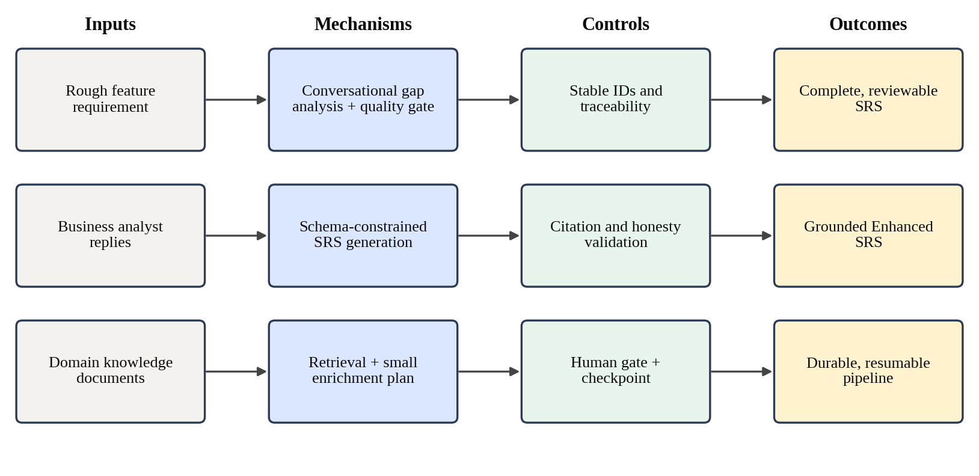
Figure 2.1: Conceptual framework for the requirement, domain and orchestration component

3 RESEARCH METHODOLOGY

3.1 Research Design
This is design-science research in the sense described by Hevner et al. [16]: I built an artefact to address a specific problem and evaluated it in the setting it was built for. There is no shared benchmark for going from a rough requirement to an approved, domain-grounded specification inside an agent pipeline, so a benchmark comparison was not available. Instead, the evaluation combines controlled experiments on individual mechanisms with a case study of the full pipeline on real features.
The work followed build-and-evaluate cycles across the project's milestones, between June and August 2026. Each cycle added or changed one mechanism, tested it against hand-built fixtures, and then ran it on real feature data. Several of the design decisions in Chapter 4 came directly out of these cycles. The clearest example is the Domain Agent's original design, which asked the model to return the full enhanced specification; testing showed that this failed with every model we tried, and the design was replaced. I treat these failures as findings in their own right rather than as dead ends to leave out.
Evaluation took place at two levels. At the component level, I tested the parts I built in isolation: the quality gate, the revision patcher, chunking, the plan validator, the merge logic and the state graph. At the pipeline level, my component was evaluated as part of the team's case study, which carried three features through all seven stages and included controlled experiments on retrieval, human gates and checkpoint recovery.

3.2 Data, Participants and Study Materials
The study materials were the domain knowledge base, the features used in the case study, the language models, and the artefacts the pipeline produced.
The e-commerce knowledge base contains five plain-text documents written for the project, each covering one area of e-commerce practice. Table 3.1 lists them. They are deliberately short and specific, so that a retrieved passage carries one clear convention, such as merging a guest cart on login or locking an account after repeated failed logins.
Table 3.1: Domain knowledge base used in the evaluation
Document | Size | Main conventions covered
product_catalog_and_inventory.txt | 2.6 KB | Products versus variants, SKU per variant, stock counts
checkout_and_cart_conventions.txt | 2.4 KB | Guest cart merge on login, cart quantity rules
order_lifecycle_states.txt | 2.4 KB | Canonical order states and allowed transitions
user_account_and_authentication.txt | 2.4 KB | Account lockout after failed attempts, account rules
payment_and_pci_basics.txt | 2.3 KB | Never storing raw card data, tokenisation

The case study used three e-commerce features of increasing complexity: Item Listing (a basic create, read, update and delete feature), Authentication and Authorization, and Shopping Cart. I also use a run of an "Add & List Items" feature in a retail store project as a worked example in Chapter 6, because its full artefact history, including four versions of the Enhanced SRS, is available in the project's artefact store.
The default model was qwen3-coder, served locally through Ollama. It replaced an earlier default after that model could not reliably follow the structured JSON schemas the pipeline depends on. During the Domain Agent's development, the original full-regeneration design was also tried with qwen3-coder, gemma4 and llama3.
No external human participants took part. The reviewer decisions recorded in the pipeline were made within the project, and no personal data was collected. Section 6.3 discusses what this means for validation.

3.3 Experimental and Study Procedure
Four procedures were used.
Retrieval ablation. To find out whether retrieval actually improves the specification, rather than assuming it does because retrieved text appears in the output, the same requirement request was run through the domain stage twice with the same model configuration, once with retrieval enabled and once with it disabled. The two outputs were then compared on the number of requirements, the number that were useful domain requirements, the number of requirements that were missing, and the number of human revisions needed.
Checkpoint recovery trials. One real, unplanned backend failure during development showed that a paused pipeline could recover, but a single incident cannot establish a recovery rate. The team therefore introduced a controlled interruption at each of the seven stage boundaries, after the state had been saved, and judged a recovery successful only if the pipeline resumed at the correct next stage without losing the earlier approval decision.
Human-gated case study. Each feature was carried through all seven stages. At every stage the team recorded the artefact produced, what the reviewer saw, the decision taken, and any revision requested. For my component, the relevant records are the SRS and Enhanced SRS versions and the reasons for each revision. The team also ran the pipeline with human gates switched on and off to compare quality and cost.
Component testing. Throughout development, deterministic parts of the component were tested against hand-built fixtures with no model call, so the tests give the same result on every run. Parts that call a model were additionally checked by hand against real feature data at each milestone, because a response can satisfy its schema and still be wrong in substance.

3.4 Measures and Evaluation Metrics
Table 3.2 lists the measures used for each research question.
Table 3.2: Measures used for each research question
RQ | Measure | How it is obtained
RQ1 | Requirements generated; useful domain requirements; missing requirements; human revisions | Retrieval ON/OFF comparison on the same request and model
RQ2 | Sections and identifiers preserved; items added or changed; failure modes observed | Fixture tests of the merge; inspection of real Enhanced SRS versions; earlier full-regeneration attempts
RQ3 | Correct resume per interrupted stage; recovery rate | Seven controlled interruptions; real failure; orchestrator tests
RQ4 | Revisions requested at the early stages and their causes; quality difference with gates on and off | Case study records; human-gates comparison
Cost | Total time, LLM calls, retries, tokens per run | Execution logs

3.5 Data Analysis
The analysis is descriptive. With one ablation request, seven recovery trials and three features, there is not enough data for statistical tests, and I have avoided presenting the results as if there were. Counts and rates are reported directly and compared between conditions, and every number is accompanied by what it can and cannot show. Qualitative evidence, such as the content of a revision request or an addition the Domain Agent should not have made, is reported alongside the numbers because it often explains them.

3.6 Ethics, Privacy, Security and Responsible AI
Several design choices in my component follow from responsible-AI concerns rather than from function alone. The default model runs locally, so a team's requirements and knowledge documents do not have to be sent to an external service. Uploaded knowledge documents are restricted to PDF, Word, text and Markdown files of up to 20 MB, and a document attached to a requirement conversation is read once for its text and then discarded rather than stored.
The more important concern is honesty about what the model knows. The Requirement Agent never presents an assumed value as if it had been given: every field it fills by default is recorded in the specification's assumptions, and a person who confirms a specification despite the quality gate must give a reason, which is written into the document. The Domain Agent may only add content it can cite, either from a retrieved passage or from the reviewer's own comment, and it may not claim domain additions when nothing was retrieved. These rules exist so that a reviewer can tell grounded content from guesses.
Finally, no stage can move the pipeline forward on its own judgement at the gated stages. A person makes every approval decision, and the system records who approved what. Chapter 7 returns to the limits of this, in particular the risk that reviewers approve without reading carefully.

3.7 Reproducibility and Research Artefacts
All of the component's code, prompts, schemas and tests are in the team's shared repository. The parameters that affect results are held in one configuration module and are listed in Table 3.3. Every artefact the pipeline produces is saved as a numbered version in JSON and Markdown, and as a PDF for the specifications, so the outputs reported in Chapter 6 can be inspected directly.
Table 3.3: Configuration parameters relevant to reproducing the results
Parameter | Value
Default LLM (one-shot calls) | qwen3-coder via Ollama
Embedding model | sentence-transformers/all-MiniLM-L6-v2
Chunk size / overlap | 900 / 150 characters
Retrieved chunks per query (top-k) | 6
Retrieval query length cap | 3,000 characters
Pinned document caps | 6 chunks per document, 12 in total, 16 retrieved overall
Questions per conversation turn | At most 3
Attached document cap | 8,000 characters
Vector store | ChromaDB persistent collection "domain_knowledge"
Checkpoint store | MongoDB collections langgraph_checkpoints and langgraph_checkpoint_writes

Reproducing the pipeline-level results requires a MongoDB database, a local Ollama server with the default model, and the knowledge base ingested into ChromaDB. Because model output is not fully deterministic, a repeated run will not produce word-for-word identical artefacts; the structure, identifiers and validation behaviour, however, are deterministic by design.

4 PRODUCT AND SOLUTION DESIGN

4.1 Requirements
The requirements for my component came from three places: the team's objectives for the whole pipeline, the needs of the downstream agents that consume the specification, and problems discovered while building it. Table 4.1 lists the functional requirements and Table 4.2 the non-functional ones.
Table 4.1: Functional requirements of the component
ID | Requirement
C1-FR-01 | Hold a conversation with the business analyst that asks at most three questions per turn about what is still missing
C1-FR-02 | Accept replies as free text or as an attached document, and let the analyst edit an earlier reply and regenerate from that point
C1-FR-03 | Check the draft specification with a deterministic quality gate before it can be confirmed, and record any override with its reason
C1-FR-04 | Generate a schema-valid SRS with stable identifiers (FR, NFR, AC, VR, US) and a traceability table
C1-FR-05 | Save every SRS as a numbered version in JSON, Markdown and PDF
C1-FR-06 | Revise an SRS by applying only the changes the reviewer asked for, and report any request that could not be matched
C1-FR-07 | Ingest domain documents (PDF, DOCX, TXT, MD) into a vector store, globally or per project
C1-FR-08 | Retrieve knowledge relevant to the approved SRS, including every chunk of any document the reviewer explicitly references
C1-FR-09 | Propose cited additions and enrichments, validate them, and merge them into an Enhanced SRS with each change flagged
C1-FR-10 | Produce a Domain Improvements report stating what changed, why, and from which source
C1-FR-11 | Run the seven stages as one state graph per feature, pausing at each gated stage until a person decides
C1-FR-12 | Resume the graph at the right point when a decision arrives, including after a backend restart
C1-FR-13 | Allow only one approved version of the SRS and of the Enhanced SRS at a time, and allow an approval to be revoked until the next stage has started
C1-FR-14 | Let each agent use its own model and provider (Ollama, OpenAI or Anthropic)

Table 4.2: Non-functional requirements of the component
ID | Quality | Requirement
C1-NFR-01 | Reliability | No single model failure may stop SRS generation; a deterministic fallback must always produce a usable document
C1-NFR-02 | Recoverability | Pipeline state must survive a process restart and resume without losing approvals
C1-NFR-03 | Integrity | Requirement identifiers must never be changed or invented by the model during enrichment or revision
C1-NFR-04 | Honesty | Assumed values and uncited content must be visible to the reviewer, never presented as given
C1-NFR-05 | Privacy | The component must work with a locally hosted model so project data can stay on the machine
C1-NFR-06 | Maintainability | Each agent must be a self-contained package; the validator and merge logic must contain no domain-specific rules
C1-NFR-07 | Testability | Deterministic logic must be testable without calling a model
C1-NFR-08 | Responsiveness | Long model calls must stream partial output to the interface so the analyst is not left waiting blind

4.2 Component Architecture within the Complete Solution
Figure 4.1 places my component within the complete system. The analyst and the reviewers work through a React interface, which calls the FastAPI backend. Within the backend, my component consists of the Requirement Agent, the Domain Agent, the approval service, the graph orchestrator and the LLM provider service. The Requirement and Domain agents write their artefacts to the versioned artefact store; the approval service records decisions and, when a gated artefact is approved, tells the orchestrator to resume. The orchestrator keeps its checkpoints in MongoDB, and the Domain Agent queries ChromaDB.
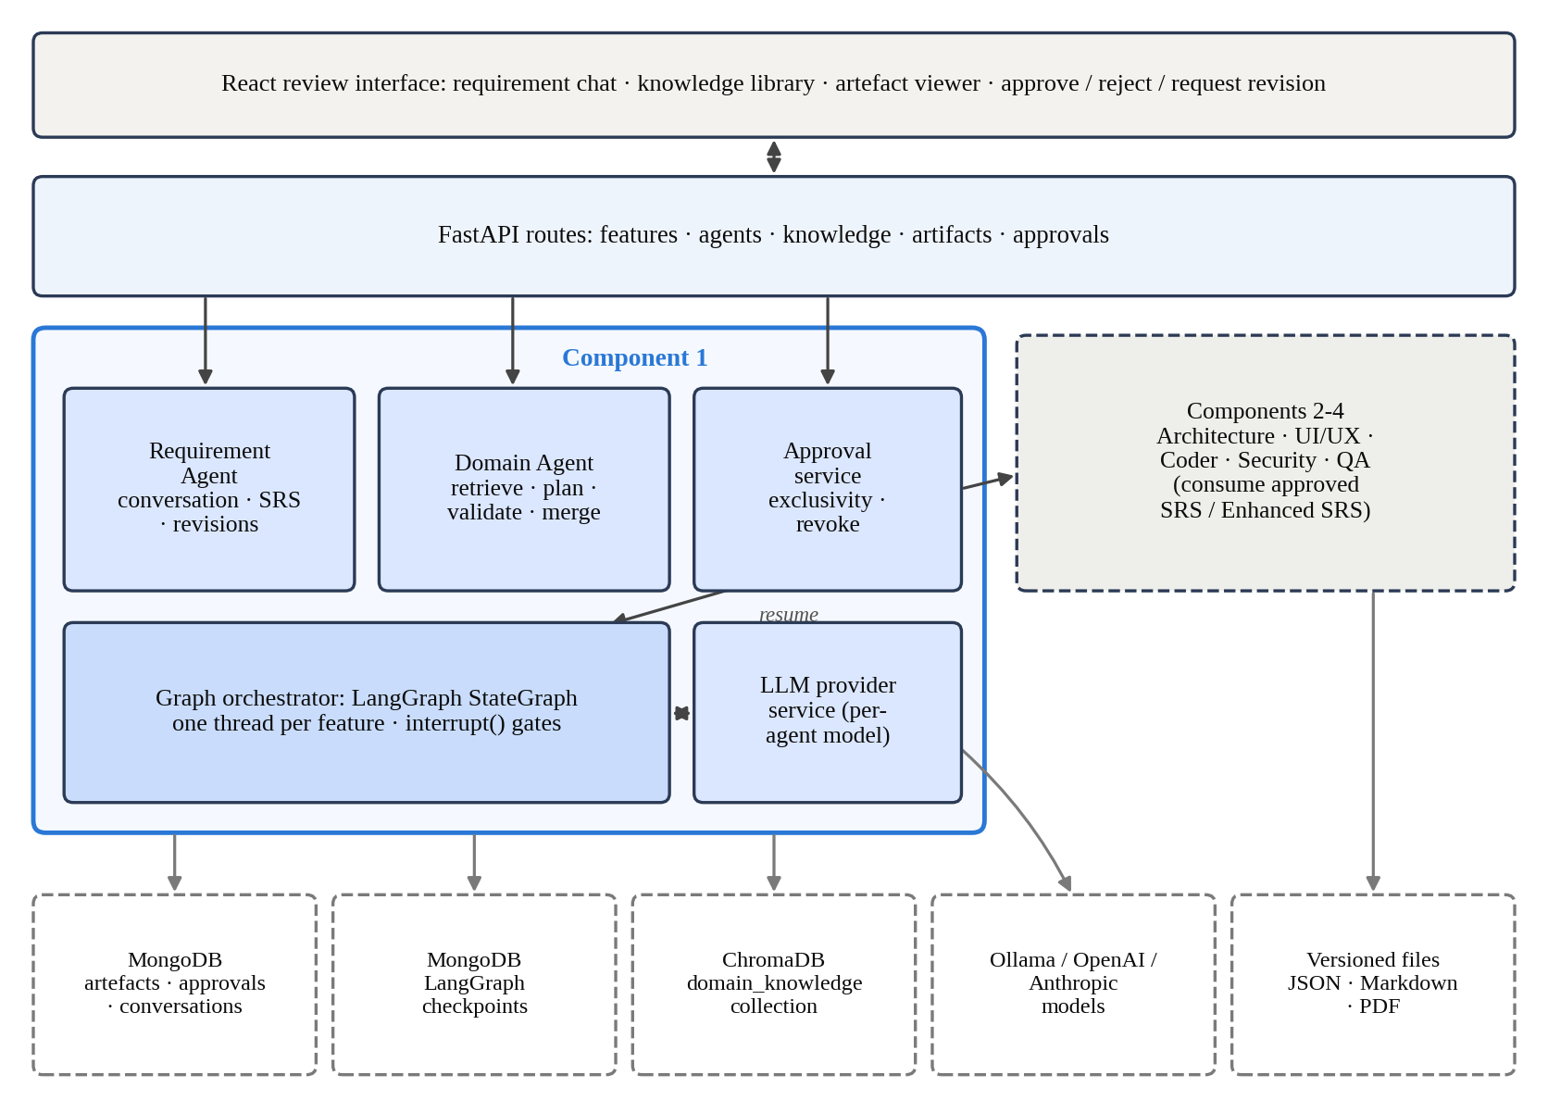
Figure 4.1: The component's place in the complete AutoForge architecture
The boundary with the other components is the approved artefact. The Architecture, UI/UX and Coder agents never call my agents directly. They read the latest approved Enhanced SRS, or the approved SRS if no Enhanced SRS has been approved, and the orchestrator runs them in order. This keeps the components loosely coupled: as long as the specification keeps its agreed shape, any agent can change its internals without breaking the others.

4.3 Design Alternatives and Decisions
Several decisions shaped the component. Table 4.3 summarises them, the alternative that was considered or tried, and the reason for the choice. The most important of these are explained in more detail below.
Table 4.3: Main design decisions
Decision | Alternative | Reason for the choice
Conversation before generation | One-shot form submitted to the agent | Gaps are filled by asking, not guessing; vague fields are caught before they reach the Architecture Agent
Deterministic quality gate | Ask the model whether the draft is ready | Gives the same answer every time and can be tested; a model is not a reliable judge of its own gaps
Small enrichment plan + Python merge | Model returns the full enhanced SRS | Full regeneration dropped sections, omitted keys or truncated output with all three models tried
Revision as targeted operations | Model retypes the whole SRS with the change | A requested change either happens or is reported as unmatched; it cannot silently disappear
Deterministic retrieval | Model decides what to retrieve through tool calls | Predictable, testable retrieval on the simpler one-shot model path
ChromaDB | MongoDB Atlas Vector Search | No extra index infrastructure at this scale; persistent local storage
Local sentence-transformer embeddings | Embeddings from the chat model provider | Retrieval does not depend on which chat provider an agent uses
LangGraph with MongoDB checkpointer | In-memory state, or calling agents in sequence by hand | Native pause and resume; state survives a restart
Approval resumes the graph | Graph polls for decisions | A decision takes effect immediately and the approval itself is the single source of truth

The decision that cost the most to reach was the move from full regeneration to a small plan. The first version of the Domain Agent asked the model to return the entire enhanced specification together with a summary of changes. Real end-to-end tests with three locally hosted models, qwen3-coder, gemma4 and llama3, showed the same failure pattern: required sections were silently dropped, top-level keys went missing, and long outputs were truncated or malformed. The problem was not the particular model but the task. Asking any model to reproduce a large document word for word, while changing only a few items, gives it many chances to make an unrequested change. The replacement asks the model only for the changes, as a short list, and leaves the copying to ordinary code that cannot make that mistake. The same reasoning later led me to redesign SRS revision in the same way.

4.4 Detailed Design

4.4.1 Conversational requirement elicitation
A feature starts with a short description, often a sentence or two. Rather than generating an SRS from that directly, the Requirement Agent runs a conversation. In each turn it makes one small model call, the gap analysis, which reads what is known so far, extracts anything new from the analyst's last reply, and asks at most three questions about what is still missing. Each question comes with a realistic example answer, so the analyst can adapt an example instead of writing from scratch. The known answers and a preview of the SRS are updated after every turn and stored, one document per feature, in MongoDB. Figure 4.2 shows the flow.
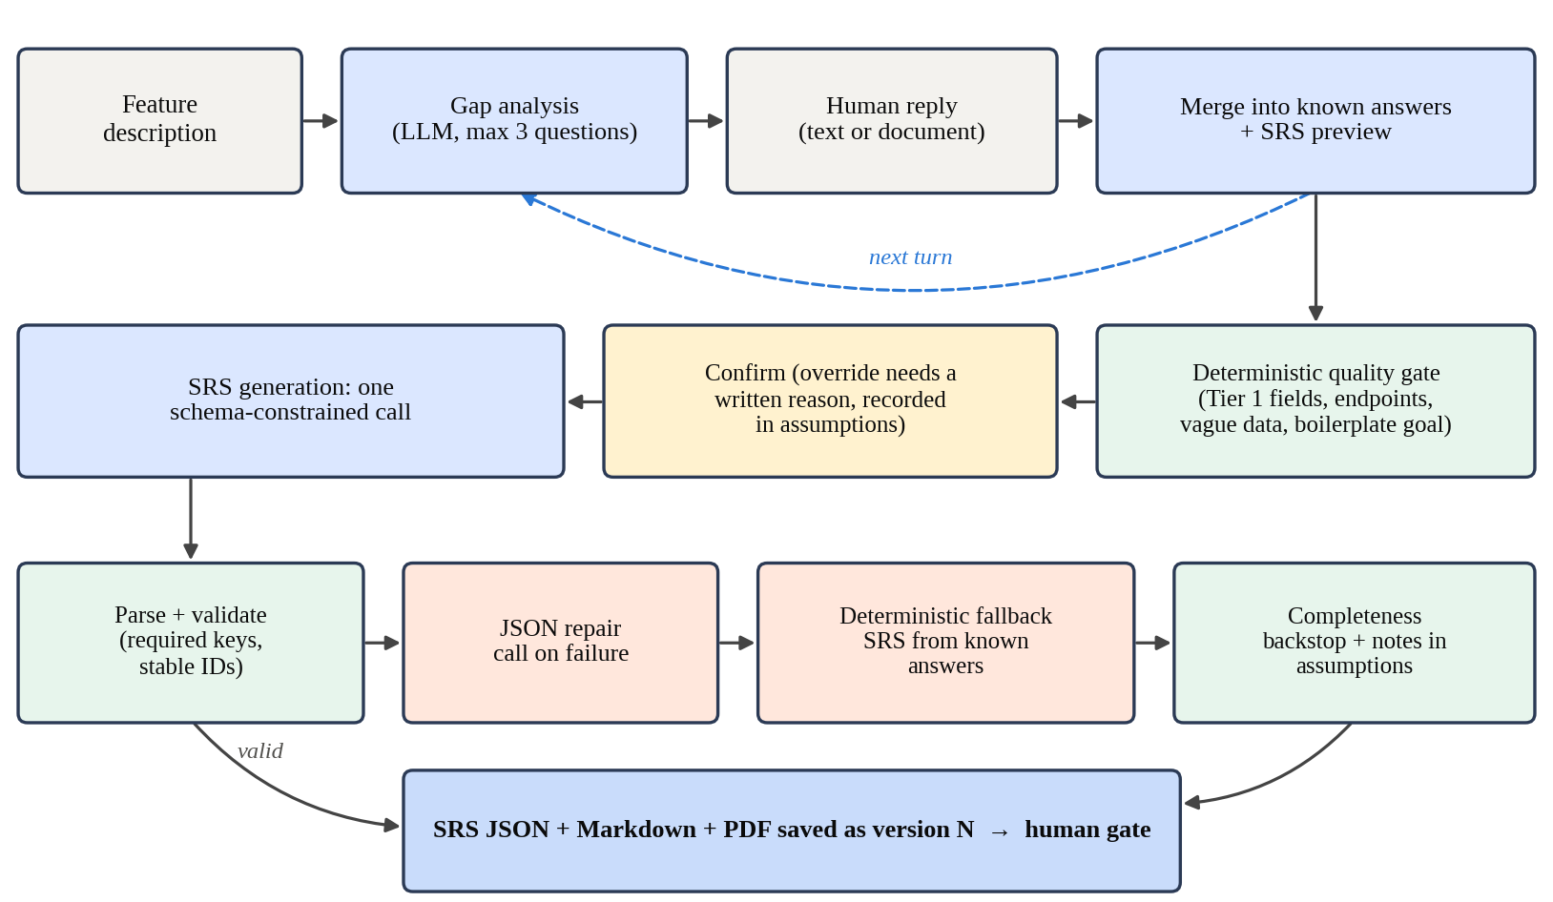
Figure 4.2: Requirement elicitation, quality gate and SRS generation
Not every field is equally important, so the questions are prioritised in three tiers. Tier 1 contains the functional requirements and the data requirements, because these are the fields the Architecture Agent depends on most heavily; a vague pair of data requirements once produced a broken architecture plan with single-field entities. Tier 2 contains the business goal, user roles, non-functional requirements, acceptance criteria and out-of-scope items, which are asked about when relevant and otherwise defaulted. Tier 3 contains the technology stack, architectural style, constraints and UI and API expectations. API and UI expectations were moved to Tier 3 after feedback that forcing an analyst to list exact endpoints was unnecessary friction: the agent can infer conventional REST endpoints from the functional and data requirements, and still keeps any the analyst volunteers.
The analyst can also attach a document to a reply. Its full text is read and passed to the gap analysis, capped at 8,000 characters so that a long document cannot silently overflow the model's context in the middle of a field. An earlier reply can be edited, in which case the conversation is rewound to the state just before that reply and regenerated from there.
Before the analyst can confirm, a deterministic quality gate checks the SRS preview. It reports a reason, and blocks confirmation, if there are no functional requirements; if the only functional requirement simply restates the feature description; if an API expectation does not look like a real "METHOD /path" endpoint; if a data requirement reads like a vague sentence rather than a field; if any Tier 1 field was assumed rather than answered; or if the business goal is still the generic template. A data requirement with a field name followed by a type or note, such as "name: string" or "createdAt (set automatically)", is treated as structured however long it is; this rule was added after the gate wrongly flagged a well-annotated field as vague. The gate never prevents a person from confirming, but an override must come with a reason, and that reason is written into the SRS's assumptions so it stays visible to every later reviewer.

4.4.2 SRS structure and generation
The SRS is a JSON document with a fixed set of sections, listed in Table 4.4. Five of them hold items with stable identifiers: functional requirements (FR-001 onwards), non-functional requirements (NFR), acceptance criteria (AC), validation rules (VR) and user stories (US). A traceability section links each functional requirement to its acceptance criteria. The JSON is the form other agents read; a Markdown version and a PDF are generated from it for people.
Table 4.4: Sections of the generated SRS
Group | Sections
Identification | project_id, project_name, project_type, feature_id, feature_name
Context | target_stack, architectural_style, business_goal, scope, out_of_scope, user_roles
ID-tagged requirements | functional_requirements (FR), non_functional_requirements (NFR), acceptance_criteria (AC), validation_rules (VR), user_stories (US)
Plain-list details | input_requirements, output_requirements, ui_expectations, api_expectations, data_requirements
Risk and context | constraints, assumptions, risks, dependencies
Links | traceability (each FR with its related acceptance criteria)

Generation uses a single schema-constrained call whose prompt tells the model to return JSON only, use stable identifiers, stay within the feature, and record the architectural style only as a preference, since designing the architecture is the next agent's job. The response then passes through a reliability ladder. It is parsed and validated: fourteen required keys must be present, and every functional requirement, non-functional requirement and acceptance criterion must have an identifier and a description. If that fails, a second call asks the model to repair the JSON. If the repair also fails, or the model could not be reached at all, a deterministic fallback builds the SRS directly from the known answers, records the failure reason, and adds a risk entry saying so. The pipeline therefore always produces a document, and the reviewer can always tell how it was produced.
Two deterministic steps run on every SRS regardless of which path produced it. The first normalises plain-list sections that the model sometimes returns in the identifier-and-description shape of the requirement sections. The second is a completeness backstop. The generation prompt did not originally require every section to be non-empty, and the model did return empty user stories in practice. The backstop fills any empty section from content that is already reliable, for example one user story per user role, or constraints derived from the stack and architectural style, and writes a note for each such fill into the assumptions. It never claims an empty risks list means there are no risks; it says the risks were not evaluated.

4.4.3 Revision through targeted operations
When a reviewer asks for a change, the agent does not ask the model to rewrite the SRS. It asks for a short list of operations, each one of add, remove, modify or set, aimed at a named section. Python then applies them. A new item receives the next free identifier in its section; a modified item keeps its identifier and has its description replaced; a removal matches by identifier, exact text or a distinctive part of the text. If an operation cannot be matched, it is reported back rather than dropped, and malformed operations are skipped rather than allowed to fail the whole revision. After a functional requirement is added or removed, the traceability section is rebuilt so it never points at something that no longer exists.

4.4.4 Knowledge ingestion and retrieval
Figure 4.3 shows the domain pipeline. Ingestion happens once per document. The text is extracted from PDF, Word, text or Markdown files, split into overlapping chunks of 900 characters with 150 characters of overlap, embedded with the all-MiniLM-L6-v2 sentence-transformer model, and stored in a persistent ChromaDB collection. Each chunk's identifier is built from its document and position, so ingesting the same document twice updates the existing vectors instead of duplicating them. Documents uploaded to a project are tagged with that project's identifier so retrieval can be limited to them.
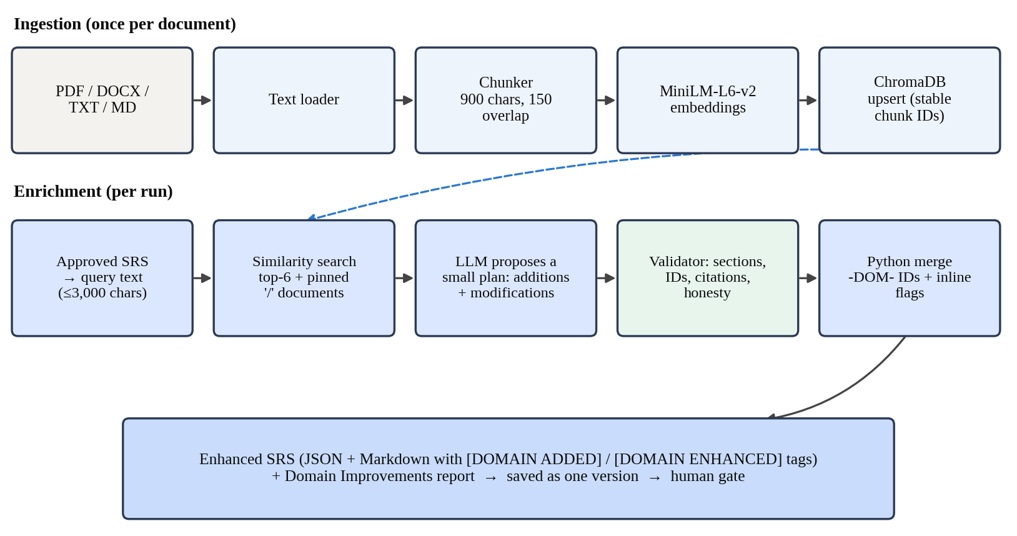
Figure 4.3: Domain knowledge ingestion and the enrichment pipeline
At run time, the Domain Agent builds a retrieval query from the approved SRS. The query uses the descriptive parts of the specification, such as the feature name, business goal and functional requirements, and leaves out sections like constraints and non-functional requirements that would pull retrieval towards generic matches. It is capped at 3,000 characters. Retrieval returns the six closest chunks. A reviewer can also reference a document explicitly by typing "/" in the chat; every chunk of a referenced document is then included, re-ranked by relevance if the document is large, within caps of six chunks per document, twelve pinned chunks in total and sixteen chunks overall. Retrieval is ordinary Python; the model is not given a search tool.

4.4.5 Enrichment plan, validation and merge
The model receives the SRS and the retrieved chunks, each labelled with its source, and is asked for a plan with two lists. Additions name a target section, a description, a rationale and a citation. Modifications name an existing item's identifier and an enhanced description. The model never assigns identifiers.
The plan is then validated item by item. An addition must target a section that exists; a modification must refer to an identifier that exists. Every item must cite either a chunk that was actually retrieved in this run or, when the reviewer typed a comment, the reviewer's own words, recorded as "human_provided". An honesty check rejects any addition claimed when nothing was retrieved and the reviewer gave no comment. Items that fail are dropped individually with a reason, so one bad guess does not throw away the rest of the plan. If the model's response cannot be used at all, a fallback plan makes no changes and explains why, rather than inventing content.
Finally, Python merges the valid plan into a full copy of the SRS. New items get identifiers with a "-DOM-" marker, such as FR-DOM-001, continuing after any existing ones. A modified item keeps its original description alongside the enhanced one. Every changed item carries its origin and citation, and the Markdown version tags additions as [DOMAIN ADDED] and changes as [DOMAIN ENHANCED]. A separate Domain Improvements report lists what changed, why, and which knowledge sources were used. Because the merge is ordinary code, the structural problems of the old design, such as dropped sections or renumbered identifiers, cannot occur.
Revising an Enhanced SRS needs one more capability: the enrichment plan can only add or enhance, but a reviewer may want something removed. The Domain Agent therefore reuses the Requirement Agent's revision operations for direct edits, since both documents share the same shape.

4.4.6 Orchestration as a checkpointed state graph
The orchestrator builds one LangGraph state graph, shown in Figure 4.4. Each of the seven stages has a node. The five stages whose output a person must approve before the pipeline continues (requirement, domain, architecture, UI/UX and coder) each have an extra approval node, which calls LangGraph's interrupt function with the feature, the stage and the artefact identifiers to review. The graph stops there. A router after each approval node sends the pipeline to the next stage if the decision was "approved", and back to the same stage's node if it was a rejection or a revision request.
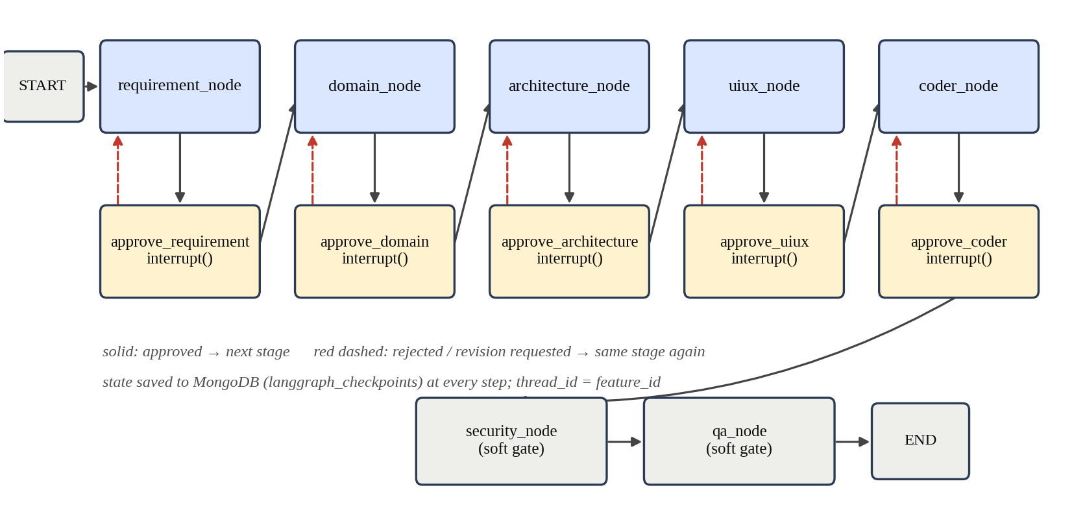
Figure 4.4: The orchestration state graph with five hard approval gates and two soft gates
The graph is compiled with a MongoDB checkpointer that saves its state to two collections, langgraph_checkpoints and langgraph_checkpoint_writes, after every step. Every call uses the feature's identifier as the thread identifier, so each feature has its own independent pipeline and a decision made hours or days later, by any process that can reach the database, resumes the right one. The orchestrator exposes three operations: start a feature's pipeline, resume it with a decision, and report which node it is waiting at.
The Security and QA stages run as soft gates in the current implementation. They run automatically after the coder stage, and their reports go to a person for review through the normal approval flow, but the graph does not stop to wait for that decision. A critical security finding is surfaced on the report so the reviewer can send the work back to the Coder Agent. This differs from the description in our research paper, where every stage pauses; I return to this difference in Section 7.5.
The requirement node is a pass-through. The Requirement Agent is driven by its own conversation and confirmation endpoints, because elicitation involves many turns with the analyst, not one call. The graph simply waits at the requirement gate until the resulting SRS is approved, and the approval resumes it.

4.4.7 Approval and versioning
Every artefact is stored with its feature, agent, type, format, version number and approval status, which is one of pending, approved, rejected or revision requested. The approval service enforces the rule that nothing moves forward unless it has been approved. When a person approves a gated artefact, the service records the decision and resumes the graph. For the SRS and the Enhanced SRS, only one version may be approved at a time: approving a new version returns the previously approved one to pending. This was added after a user found two SRS versions marked as approved and could not tell which one the Domain Agent would use. An approval can be revoked, but only until the pipeline has moved on to the next stage.

4.5 Standards and Professional Practice
I followed several established practices in the design. Requirements carry stable, prefixed identifiers and a traceability table, so that later artefacts can refer to them, which is the precondition the traceability literature [6], [7] points to. Acceptance criteria are written in the Given-When-Then form, functional requirements carry a priority such as Must Have or Should Have, and inferred API expectations follow REST conventions.
On the engineering side, all inputs and outputs are defined as typed schemas and validated, deterministic logic is separated from model calls so that it can be tested without a model, and every agent is its own package with its own prompt, schema and modules. Configuration and secrets, such as database connection strings and API keys, are read from environment settings rather than written into the code, and all work was kept under version control in the team's shared repository. Model output is treated as untrusted input: it is parsed, validated and, where necessary, rejected before it can change a stored artefact.

5 IMPLEMENTATION

5.1 Development Environment and Technology Stack
The component is written in Python and runs inside the team's FastAPI backend. Table 5.1 lists the technologies it uses and why each was chosen. Most of the choices were made to keep the system runnable on a single developer machine, without paid services, while leaving the option of a hosted model open.
Table 5.1: Technology stack used by the component
Concern | Technology | Why it was used
Web API | FastAPI, Pydantic | Typed request and response schemas, validation and streaming responses
Orchestration | LangGraph StateGraph | Explicit stage graph with native interrupt and resume
Checkpoints and artefacts | MongoDB (MongoDBSaver) | Already used by the team for artefacts; durable state for the graph
Vector store | ChromaDB (persistent client) | Local, file-backed vector storage with metadata filters
Embeddings | sentence-transformers all-MiniLM-L6-v2 | Small, fast, runs locally, independent of the chat model
Chunking | RecursiveCharacterTextSplitter | Splits on paragraph and sentence boundaries before characters
Default LLM | qwen3-coder via Ollama | Runs locally and followed the JSON schemas reliably
Optional LLMs | OpenAI and Anthropic APIs | Per-agent override when a stronger hosted model is wanted
Documents | Markdown builder, PDF builder | Human-readable SRS and Enhanced SRS from the same JSON
Frontend | React 19, Vite, Tailwind CSS 4, TanStack Query | The team's shared interface stack
Testing | pytest | Fixture-based tests of the deterministic logic

5.2 Implementation of the Core Modules
Each agent is a self-contained Python package with an entry point, a prompt module, a schema module and its own stage-specific modules. Table 5.2 lists the main modules of my component with their size, which gives a rough idea of where the effort went. The Requirement Agent is the largest because it carries both the conversation and the generation and revision logic.
Table 5.2: Main modules of the component
Module | Lines | Responsibility
requirement_agent/agent.py | 1,756 | Conversation endpoints, SRS generation ladder, completeness backstop, revision
requirement_agent/conversation_engine.py | 541 | Gap analysis, tiered questions, known-answer merging
requirement_agent/prompt.py | 431 | Gap-analysis, generation, repair and revision prompts
requirement_agent/revision_patcher.py | 333 | Applies add, remove, modify and set operations
requirement_agent/conversation_quality_gate.py | 119 | Deterministic readiness checks
domain_agent/agent.py | 1,273 | Retrieval query, plan call, merge, report, revision
domain_agent/domain_validator.py | 488 | Section, identifier, citation and honesty checks
rag/ (four modules) | 364 | Loading, chunking, embedding and the ChromaDB store
graph_orchestrator | 335 | State graph, approval nodes, router, checkpointer
approval_service | 563 | Decisions, version exclusivity, revocation, resuming the graph
llm_provider_service | 384 | Provider abstraction and per-agent model selection

5.2.1 Requirement Agent
The conversation is exposed through endpoints to start a conversation, send a reply, stream a reply, edit an earlier reply, and confirm. Each turn calls the gap-analysis prompt and merges the extracted answers into the stored conversation. The streaming endpoint sends partial output back to the interface while the model is still working, which made a noticeable difference to how responsive the chat felt with a local model.
The quality gate is a single function that takes the SRS preview and the set of assumed fields and returns a list of reasons. Keeping it free of model calls meant it could be tested exhaustively and changed safely. The rule that was hardest to get right was the one for vague data requirements. The first version flagged any data requirement longer than six words, which wrongly blocked a well-written field such as "name -- string, required (user's full name or display name)". The final rule first checks whether the line looks like a field specification, meaning a field name followed by a colon, a dash or a note in brackets, and does not start with a sentence word such as "the" or "when". Only lines that fail this check are judged by their length.
Generation follows the ladder described in Section 4.4.2. In code, each rung is a separate function and each returns either a validated SRS or a reason for failure, so the reason can be carried into the fallback document. The excerpt below shows the shape of the top-level logic, simplified for readability.
def generate_srs(answers, feature):
try:
raw = llm.invoke(generation_prompt(answers, feature))
srs, error = parse_and_validate(raw)
if srs is None:
fixed = llm.invoke(repair_prompt(raw, error))
srs, error = parse_and_validate(fixed)
except LLMUnavailableError as exc:
srs, error = None, str(exc)
if srs is None:
srs = fallback_srs(answers, feature, reason=error)
srs = normalise_plain_lists(srs)
return ensure_srs_completeness(srs)
The revision patcher works on twelve plain-list sections, the four identifier sections that can be edited directly (FR, NFR, AC and VR), the user stories, and three scalar fields: the business goal, the architectural style and the target stack. Matching for removal and modification tries the identifier first, then the exact text, then a distinctive substring, because reviewers rarely quote a requirement word for word.

5.2.2 Retrieval pipeline
The retrieval code is split into four small modules: a loader that dispatches on file extension, a chunker, an embedder, and a store wrapper around ChromaDB. The embedding model is loaded lazily on first use, so starting the backend does not wait for it, and the embeddings are normalised before they are stored. Knowledge documents are uploaded through an endpoint that accepts files of up to 20 MB, either into the shared knowledge base or into a single project's space.

5.2.3 Domain Agent
The Domain Agent's run function builds the retrieval query, collects the retrieved and pinned chunks, calls the model for a plan, validates it, merges it, and writes three artefacts: the Enhanced SRS as JSON and Markdown (with a PDF on request) and the Domain Improvements report. The validator is the second-largest module of the agent. Its output is a filtered plan plus a list of dropped items, each with a reason, and the dropped items are logged so that a developer can see what the model tried to do.
Getting the citation rule right took more than one attempt. A citation must name a source document that was really among the chunks retrieved in this run, or the special source "human_provided" when the reviewer typed a comment. In testing, the local model sometimes proposed a change the reviewer had clearly asked for but left the citation empty. Dropping such a change would have ignored the reviewer, so when a comment exists, an item with no citation at all is attributed to that comment instead of being discarded. An item with no citation and no comment is still dropped. Chapter 6 shows that this leniency has a cost.

5.2.4 Orchestrator and approval service
The orchestrator builds and compiles the graph once and exposes start, resume and get-status functions. The graph and its MongoDB checkpointer are synchronous, while the agents are asynchronous. The routes that drive the graph are therefore plain synchronous handlers, which FastAPI runs in a worker thread, and each node runs its agent to completion inside that thread. If a node fails, for example because the model server is down, the checkpoint stays at that node, so the next resume simply retries it. Calling resume on a feature with no running graph raises a specific error that the API turns into a clear message rather than a server error.
The approval service is where a person's decision becomes pipeline movement. When an artefact is approved it updates the artefact's status, enforces the one-approved-version rule for the SRS and the Enhanced SRS, and resumes the graph. A failure in a downstream agent during that resume is caught and logged rather than returned as an error, because the human's approval itself succeeded and should be recorded as such; the failed stage can be retried.

5.2.5 LLM provider service
All model calls go through a provider service that hides the differences between Ollama, OpenAI and Anthropic. Each agent can be given its own provider and model, so, for example, the Requirement Agent could run on a hosted model while the Domain Agent stays local. When no override is set, the local default is used. API keys are read from the environment and never stored with the artefacts.

5.3 Integration with the Complete Solution
My component connects to the rest of AutoForge in three ways. First, through the artefact store: the Architecture Agent, UI/UX Agent and Coder Agent read the latest approved Enhanced SRS, or the approved SRS when there is none. Applying this rule everywhere stopped a class of bugs in which a downstream agent read a draft version. Second, through the orchestrator: every agent is called by its node in the graph, so adding or reordering a stage is a change in one place. Third, through the frontend, where I built the requirement conversation chat, the Domain Agent chat with its document picker, the knowledge panel, the Domain Improvements viewer and the SRS output panel.
Integration produced several of the changes already described. The Architecture Agent's broken entity model led to the Tier 1 data requirements and the stricter quality gate. Finding two SRS versions marked as approved, with no way to tell which one the Domain Agent would use, led to the single-approved-version rule. An early version of the graph approved the domain stage automatically; I moved it back to a hard gate because the Enhanced SRS is exactly the kind of artefact a person should check before design starts.

5.4 Testing and Quality Assurance
Testing focused on the deterministic parts of the component, because those are the parts whose behaviour the rest of the system relies on. Table 5.3 summarises the test files and the number of test functions in each; Appendix A gives the full catalogue.
Table 5.3: Automated tests for the component
Area | Test files | Test functions
Requirement Agent | conversation, revision patcher, completeness, normalisation, PDF builder | 65
Domain Agent and RAG | fallback, validator, chunking, Markdown builder, PDF builder, retrieval query | 42
Orchestration and approval | graph orchestrator, SRS exclusivity, revoke | 25
LLM provider | Ollama provider | 2
Total | 15 files | 134

Some tests check behaviour that matters most to the pipeline. The orchestrator tests confirm that the graph can be resumed by a new orchestrator instance, which simulates a restart; that the domain stage cannot proceed without an approved SRS; and that a rejection loops back to the same stage. The validator tests feed in plans with invented identifiers, unknown sections, citations to chunks that were never retrieved and "human_provided" citations with no human comment, and check that each is dropped with the right reason.
The last recorded run of the full backend suite, on 31 August 2026, collected 1,310 tests across the team's code, of which 160 belong to my component when parameterised cases are counted. The only failure recorded for my component in that run's cache is for a test that has since been replaced, so no current test of the component is recorded as failing. Some tests need a running MongoDB database, because the shared test setup creates a user through the authentication service, which is a limitation I return to in Chapter 7.
The parts that call a model were also checked by hand at each milestone against real feature data, since an SRS can pass every schema check and still say the wrong thing. Several of the issues reported in Chapter 6, such as the irrelevant guest-checkout constraint, were found this way rather than by an automated test.

5.5 Deployment and Operation
The component is deployed as part of the AutoForge backend. Running it needs a MongoDB database, an Ollama server with the default model pulled, and a directory for the ChromaDB files. Connection strings, model names and API keys are set through environment variables. The knowledge base is loaded once through the upload endpoint and persists across restarts. Because both the graph checkpoints and the artefacts live in MongoDB, the backend process can be stopped and started at any time; features that were waiting for a decision are still waiting when it comes back.

6 RESULTS AND EVALUATION
This chapter reports the results in the order of the research questions, after first summarising what the automated tests established. Pipeline-level numbers come from the team's evaluation, reported in our research paper; I state where a result belongs to the whole pipeline rather than to my component alone. Section 6.4 then walks through a real run of my two agents on a retail store feature, including the parts that did not go well.

6.1 Component-Level Test Results
Table 6.1 lists the behaviours that matter most to the rest of the pipeline and the tests that check them. All of these were passing in the last recorded run. They do not measure quality; they establish that the deterministic rules the design depends on actually hold.
Table 6.1: Key behaviours confirmed by automated tests
Behaviour | Test file | Result
Vague or assumed Tier 1 fields block confirmation; override needs a reason | requirement_conversation | Pass
Add, remove, modify and set change only the targeted item; unmatched requests are reported | requirement_revision_patcher | Pass
Empty sections are filled from reliable content and noted in the assumptions | srs_completeness | Pass
Invented identifiers, unknown sections and unretrieved citations are dropped | domain_validator | Pass
"human_provided" is rejected when no human comment exists | domain_validator | Pass
An unusable model response gives a no-change plan with a reason | domain_agent_fallback | Pass
Chunk identifiers are deterministic and tagged with their source document | domain_chunking | Pass
A new orchestrator instance resumes a paused feature | graph_orchestrator | Pass
The domain stage cannot run without an approved SRS | graph_orchestrator | Pass
A rejection loops back to the same stage | graph_orchestrator | Pass
Only one SRS version is approved at a time | approval_srs_exclusivity | Pass
Revoking an SRS is refused once an Enhanced SRS exists | approval_revoke | Pass

6.2 Experimental Results

6.2.1 Effect of retrieval on completeness (RQ1)
The same requirement request was run through the domain stage with retrieval enabled and disabled, using the same model configuration. Table 6.2 and Figure 6.1 show the results.
Table 6.2: Retrieval ablation on one controlled request
Measure | Retrieval ON | Retrieval OFF | Change
Requirements generated | 18 | 15 | +3
Useful domain requirements | 14 | 8 | +6
Missing requirements | 2 | 7 | -5
Human revisions | 3 | 6 | -3

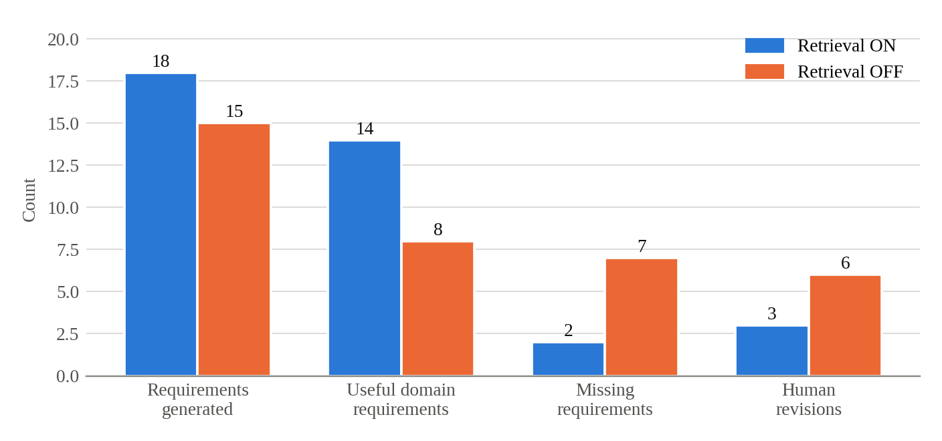
Figure 6.1: Retrieval ON versus OFF on the same request and model
The headline is not the three extra requirements; a longer specification is not automatically a better one. What matters is that the number of useful domain requirements nearly doubled while the number of missing requirements fell from seven to two, and the reviewer needed half as many revisions to reach an acceptable specification. Without retrieval, the model still produced a plausible-looking document, but it missed conventions that the knowledge base states plainly. This is the gap retrieval was meant to close, and on this request it did.
Two cautions apply. This is one request, so the numbers show an effect but not its typical size. And "useful" was judged by the team, not by an independent panel. Section 6.4 also shows that retrieval can add things that are not useful at all.

6.2.2 Small plan versus full regeneration (RQ2)
This question was answered during development rather than in a single experiment. Table 6.3 compares what was observed with the original design, in which the model returned the whole enhanced specification, and with the final design.
Table 6.3: Observed behaviour of the two Domain Agent designs
Property | Full regeneration | Small plan + Python merge
Models tried | qwen3-coder, gemma4, llama3 | qwen3-coder (default)
Required sections | Sometimes silently dropped | Always present; copied by code
Top-level keys | Sometimes missing | Always present
Long outputs | Truncated or malformed JSON | Plan is short; nothing to truncate
Identifiers | Could be renumbered or invented | Never assigned by the model
Uncited additions | Not detectable | Dropped by the validator with a reason
Bad model output | Whole run fails | Bad items dropped; total failure gives a no-change plan

The failures of the first design appeared with all three models, which is why I concluded that the task itself was the problem. With the final design, every Enhanced SRS produced in our runs kept every section and identifier of the approved SRS, because the merge code makes any other outcome impossible. This is a structural guarantee rather than a measured rate. What the small plan does not guarantee is that each addition is relevant, which Section 6.4 illustrates.

6.2.3 Checkpoint recovery (RQ3)
During development, the backend failed unexpectedly in the middle of a pipeline run. After the restart, the pipeline continued from its saved checkpoint instead of starting again. Because one incident cannot give a rate, the team then interrupted the pipeline deliberately at each of the seven stage boundaries, after the state had been saved. Table 6.4 shows the results.
Table 6.4: Controlled checkpoint-recovery trials
Trial | Interrupted after | Expected next stage | Actual next stage | Correct
1 | Requirement | Domain | Domain | Yes
2 | Domain | Architecture | Architecture | Yes
3 | Architecture | UI/UX | UI/UX | Yes
4 | UI/UX | Coder | Coder | Yes
5 | Coder | Security | Security | Yes
6 | Security | QA | QA | Yes
7 | QA | Completion | Completion | Yes

All seven trials resumed at the correct stage without losing the earlier approval decision, a recovery rate of 7 out of 7. Together with the automated test in which a new orchestrator instance resumes a paused feature, this answers RQ3 positively for the conditions tested: process restarts with the database still available. A failure of the database itself was not tested.

6.2.4 Human review at the early stages (RQ4)
In the Item Listing case study, the reviewer did not accept the first SRS. They asked for two user stories for the Admin and Manager roles, which the first version had left out, and the SRS was approved at version 2. The Enhanced SRS was then approved at version 1 without revision. The missing stories matter because they decide which screens and permissions exist. Had they been discovered after the Coder stage, the fix would have touched the architecture plan, the screen designs and the code. Caught at the requirement gate, it was a two-line change.
Across the pipeline, four of the seven stages of Item Listing needed a revision. The team also ran the pipeline with human gates switched on and off, with the results in Table 6.5. These are whole-pipeline results, so they speak to the value of gating in general rather than to my stages alone.
Table 6.5: Pipeline with human gates on and off
Measure | Gates ON | Gates OFF
Successful pipelines | 3/3 | 2/3
Average revisions | 5.0 | 1.0
QA pass rate | 91% | 78%
Security issues | 1 | 4
Escaped defects | 1 | 5
Human review effort | 36 min | 0

With gates on, more revisions were made, but fewer defects escaped and the QA pass rate was higher. The cost was about 36 minutes of review effort. For RQ4, the case-study evidence shows that review at the requirement stage did catch a real omission before any design existed.

6.3 Stakeholder and User Validation
No external users or industry stakeholders took part in the evaluation. All reviewer decisions were made within the project team, which knows the system well and may review differently from a business analyst seeing it for the first time. This is the most important gap in the validation of my component, because the value of a conversation and a quality gate depends on how real analysts respond to them.
Informal feedback inside the team did shape the design. Moving API and UI expectations from the required questions to the optional tier, accepting attached documents as answers, and allowing an earlier reply to be edited all came from team members using the requirement chat on their own features.
[Student to complete: add any feedback received from the supervisor, co-supervisor or panel at the progress presentations, or from any user who tried the requirement chat, with dates.]

6.4 Worked Example: Retail Store "Add & List Items"
To show how the component behaves on a real feature, rather than in summary numbers, this section follows the "Add & List Items" feature of a retail store project through the requirement and domain stages. All of the artefacts described here are stored in the project's output folder.

6.4.1 The generated SRS
Table 6.6 summarises the first SRS produced after the conversation.
Table 6.6: Composition of the retail store SRS, version 1
Section | Count | Notes
Functional requirements | 2 | Add an item; list items
Non-functional requirements | 3
Acceptance criteria | 5 | Given-When-Then; includes a rejected image upload case
Validation rules | 4
User stories | 2
User roles | 1 | "any user"
Data requirements | 6 | Structured field specifications
API expectations | 2 | POST /api/items and GET /api/items
Out of scope | 3
Traceability rows | 2 | One per functional requirement

The SRS is small, which is right for a small feature. Two details show the honesty rules working. The assumptions section states that the UI and API expectations were inferred rather than given, so a reviewer knows those two endpoints were the agent's suggestion. And the single user role, "any user", is exactly the kind of thing a reviewer should question; in the Item Listing case study, the same weakness is what led to the Admin and Manager stories being added.

6.4.2 The Enhanced SRS and its revisions
The Domain Agent produced four versions of the Enhanced SRS. Table 6.7 summarises them.
Table 6.7: Enhanced SRS versions for the retail store feature
Version | Sources used | Changes | Assessment
v1 | Product catalogue (2 chunks), checkout and cart (2 chunks) | FR-DOM-001 view item details; two constraints (multiple currencies, guest checkout); AC-003 error message made specific | Detail view and AC-003 useful; guest checkout irrelevant
v2 | None | No changes | Correct: the comment asked for nothing concrete
v3 | "human_provided" | GDPR constraint added | Citation not justified: the reviewer asked a question
v4 | "human_provided" | Same GDPR constraint | Repeat of v3

Version 1 shows both sides of retrieval. Adding a requirement to view an item's details, cited to the product catalogue document, is a sensible addition for a listing feature, and making the upload error message specific improves an acceptance criterion a tester will have to check. But a constraint that the system must support guest checkout has nothing to do with adding and listing items. It was retrieved because the checkout document is close to the SRS in wording, and it passed validation because it cited a chunk that was genuinely retrieved. The validator checks that a citation is real; it cannot check that the cited passage is relevant. A reviewer would need to remove it.
Version 2 is the system behaving as intended. The reviewer's comment contained no concrete request, and the agent made no changes and said so in the report, rather than inventing something to show activity.
Versions 3 and 4 expose a weakness I did not anticipate. The reviewer asked whether any compliance requirements were missing. The model answered by adding a general GDPR constraint and cited the reviewer's comment as its source, with an empty rationale. The validator accepted it, because a human comment existed and the rule only asks whether one exists, not whether it actually requested the addition. In effect, a question was treated as an instruction. The constraint may even be reasonable, but it is not grounded in the knowledge base or in anything the reviewer stated, which is exactly what the citation rule is meant to prevent. I discuss the fix in Chapter 7.
The approval status of each version is recorded in the artefact store, but I have not relied on it here, because the point of the example is what the agent produced and what a reviewer would need to catch.

6.5 Integration and Performance Results
My component was exercised in every pipeline run, since every feature passes through the requirement and domain stages and is driven by the orchestrator. In the three-feature evaluation, all three features completed all seven stages with gates on. Table 6.8 shows the execution cost of each run as recorded in the execution logs.
Table 6.8: Execution performance of the full pipeline
Run | Total time (min) | LLM calls | Retries | Tokens
Item Listing | 36.4 | 24 | 4 | 31,800
Authentication | 52.7 | 31 | 6 | 42,600
Shopping Cart | 56.8 | 34 | 7 | 47,900
Baseline | 31.2 | 18 | 3 | 25,400

These figures cover all seven stages, and the logs do not separate out the time spent in my stages, so I do not claim a per-stage figure. The number of LLM calls and retries grows with feature complexity, which is what I would expect from my stages too: a more complex feature needs more conversation turns before the quality gate is satisfied, and a longer SRS gives the model more chances to produce invalid JSON. The point that matters for the design is that retries did not stop any run, which is the purpose of the repair-and-fallback ladder.

6.6 Summary of Findings
Table 6.9: Summary of findings by research question
RQ | Finding | Strength of evidence
RQ1 | Retrieval raised useful domain requirements from 8 to 14 and cut missing ones from 7 to 2, but can also add irrelevant items | One controlled request plus a real run
RQ2 | Small plan and Python merge preserved structure and identifiers in every run; full regeneration failed with three models | Structural guarantee; repeated development observations
RQ3 | Seven of seven controlled interruptions resumed correctly with approvals intact | Seven trials, one real failure, automated test
RQ4 | The requirement gate caught missing Admin and Manager stories before design; gating reduced escaped defects pipeline-wide | One case study; one on/off comparison

7 DISCUSSION

7.1 Interpretation of the Results
The results support the main idea behind the component: let the model write, but let deterministic code and a person decide what moves forward. Each research question touched a different part of that idea.
Retrieval helped, but it is not a filter. On the controlled request, it nearly doubled the useful domain requirements and cut the missing ones by more than two thirds. On the retail store feature, it also brought in a guest-checkout constraint that had nothing to do with listing items. Both results come from the same mechanism. Similarity search finds passages that are close to the specification in wording, and most of the time closeness means relevance, but not always. The citation makes the irrelevant addition easy to spot and trace back to its source, which is better than an uncited one, but it still needs a person to remove it.
The small-plan design solved the problem it was built for. Structural failures, such as dropped sections or changed identifiers, cannot happen once the copying is done by code. The lesson I take from it is more general than the Domain Agent: whenever a model is asked to reproduce a large document in order to change a small part of it, the reproduction is the risky part, and it is better to ask only for the change. The same reasoning carried over directly to SRS revision.
Checkpointing behaved exactly as designed, with seven correct recoveries out of seven. This is less surprising than the other results, since persistence and resumption are well-supported by LangGraph and MongoDB. The value of the result is that it removes a practical objection to human gates: a gate that might be lost on a restart is a gate people will want to switch off.
Finally, the early-stage review did catch real problems. The missing Admin and Manager stories and the irrelevant retail store constraint are both cases where a few minutes of reading prevented work that would otherwise have been built on a wrong assumption.

7.2 Comparison with Related Work
Compared with MetaGPT [2], which also produces an SRS-like document, my component differs in three ways: it asks the analyst before it assumes, it grounds additions in retrieved and cited knowledge, and it holds the pipeline until a person approves the document. Compared with ChatDev [1], the requirement is an artefact with its own versions and decisions rather than a result of agent dialogue. HULA [5] found that engineers value reviewing an agent's plan before code is written; my component applies the same principle one step earlier, to the specification itself, and makes the pause survive a restart.
The use of retrieval follows the idea set out by Lewis et al. [3], but applies it to a different output. Instead of grounding an answer to a question, it grounds additions to a structured document, and it adds a check that each addition cites something that was actually retrieved. Hemmat et al. [4] identified domain grounding in LLM-based requirements engineering as under-explored, and the retrieval ablation is a small piece of evidence that it is worth exploring further.
On traceability, the component does not build the full chain from requirement to code that Gotel and Finkelstein [6] describe. What it does provide is the precondition: identifiers that stay stable through enrichment and revision, and a traceability table linking each functional requirement to its acceptance criteria. Without that, the narrow, single-link solutions that Mucha et al. [7] observe would be the best the pipeline could offer.

7.3 Implications for Practice
For teams building agent pipelines, three practical points follow from this work. First, keep a deterministic check between the model and anything that is stored or passed on. The quality gate, the plan validator and the revision patcher are all small pieces of ordinary code, and between them they prevented most of the failures we saw in early versions. Second, record assumptions where the reviewer will see them. A specification that says "these endpoints were inferred" invites the right question; one that just lists the endpoints does not. Third, make the reviewer's job easier, not just possible. Flags such as [DOMAIN ADDED], a separate report of what changed, and a quality gate that names the problem all reduce the effort of a careful review, which matters because a gate is only as good as the reading it receives.

7.4 Threats to Validity
Internal validity. The retrieval ablation used one request, and the judgement of which requirements were useful or missing was made by the team. Different reviewers might have drawn the line differently. The human-gates comparison used the same team as reviewers, who knew the system and the expected outcome.
External validity. The knowledge base is five short documents written for the project, and the features are typical e-commerce features. A larger, messier knowledge base, or a different domain, might retrieve less useful passages more often. The evaluation used one default model, so the results may not hold for every model the provider service supports.
Construct validity. Counts of requirements and revisions are a rough measure of specification quality. A specification with fewer missing requirements is better, but the count does not show how serious each missing requirement was. The execution logs also do not separate the cost of my stages from the rest of the pipeline.

7.5 Limitations
Several limitations are specific to my component.
• The citation rule checks that a citation is real, not that the cited passage supports the addition. The guest-checkout constraint passed for this reason.
• The "human_provided" rule only checks that a reviewer comment exists. A question was accepted as the source of a GDPR constraint, and the lenient handling of missing citations makes this easier. A stricter rule would require the comment to contain an explicit request, or would show such additions to the reviewer as suggestions rather than merging them.
• Security and QA run as soft gates in the current implementation, while our research paper describes all seven stages as pausing for a decision. The reports still reach a person, but the graph does not wait for them. This difference should be resolved, either by making these two stages hard gates again or by describing them as soft gates in future publications.
• Some tests depend on a running MongoDB database through the shared test setup, so the suite cannot run in isolation. The deterministic modules could be tested without it if that setup were separated.
• The quality gate uses fixed rules. They catch the vague inputs we encountered, but a determined or careless analyst can satisfy them with content that is specific in form and still wrong in substance.
• No external analyst used the requirement chat, so its usability for people outside the team is untested.
• A human gate can become a formality if reviewers approve without reading. The system records who approved each artefact, but it cannot tell whether they read it.

8 COMMERCIALISATION AND SUSTAINABILITY

8.1 Value of the Component
The team's common report sets out the commercial case for AutoForge as a whole: teams that build software with AI need to be able to see and approve what the AI produced at each stage. My component contributes two things to that case that would also have value on their own.
The first is a requirement assistant that asks before it assumes. Many small teams and agencies start a client project from a short email or a meeting note. A tool that turns that into a structured specification, asks for exactly the missing pieces, flags what it had to assume, and produces a document a client can read and sign off saves time at the stage where misunderstandings are cheapest to fix. The second is the orchestration layer: a way to run a chain of AI agents with durable human approval points, which is useful for any staged process, not only software development.

8.2 Target Users and Market Position
The first users would be the same as for AutoForge: small e-commerce development teams and agencies that build online stores for clients. Within those teams, the direct users of my component are business analysts, project leads and developers who write requirements as part of their role. Table 8.1 compares the component with the alternatives such a user has today.
Table 8.1: Alternatives for producing a feature specification
Alternative | Strength | Weakness compared with this component
Writing the SRS by hand | Full control and judgement | Slow; no domain prompts; quality depends on the writer's experience
General-purpose chat assistant | Fast, flexible | Fills gaps silently; no fixed structure or stable IDs; nothing to stop a vague draft
Role-based frameworks such as MetaGPT [2] | Specification is part of a larger pipeline | Written from model knowledge only; no human gate or durable pause
This component | Asks for gaps; quality gate; cited domain enrichment; stable IDs; human approval | Slower than a single prompt; domain quality depends on the knowledge base

8.3 Business Model and Feasibility
The component fits within the open-core model proposed in the common report. Two parts of that model depend directly on my work. The first is domain knowledge packs. Because the validator and merge logic contain no domain rules, a knowledge pack for another bounded domain, such as learning management or hospitality booking, can be added without changing the code. Curated, maintained packs are something a customer can reasonably pay for, because writing good domain documents takes expertise that a small team may not have. The second is the team edition's review features: role-based approval, revocation and an audit trail of decisions are extensions of the approval service that already exists.
Technically, the component is already feasible: it runs on a single machine with a local model and has been used on every feature in our evaluation. The domain stage is also cheaper to run than the original design, because the model returns a short plan instead of retyping the whole specification. The main operational question is the knowledge base. A pack that is too small brings in irrelevant matches, as the guest-checkout constraint showed, so packs would need to be tested with the retrieval ablation method from Chapter 3 before release.

8.4 Sustainability and Maintenance
Technical sustainability depends mostly on how well the component copes with change. Three design choices help. The provider service means a better or cheaper model can be adopted by configuration, not by rewriting agents. The deterministic gate, validator and merge code do not depend on the model, so they keep working when the model changes. And the knowledge base can be updated by uploading documents, without retraining anything.
There are also maintenance risks. The component depends on LangGraph, ChromaDB and sentence-transformers, all of which change quickly, so their versions need to be pinned and upgraded deliberately. The quality gate's rules were tuned on our own features and will need review as the component meets new kinds of requirement. And knowledge packs age: payment and data protection rules in particular change, so each pack needs an owner and a review date.
Socially, the component keeps a person in the role of deciding what the software should do. It is designed to make an analyst faster and more thorough, not to replace them, and the conversation format means the analyst is involved in every answer. The main ethical risk is the one discussed in Chapter 7: if reviewers start approving specifications without reading them, the gate stops protecting anything. Clear flags, visible assumptions and a short Domain Improvements report are meant to keep review practical.

8.5 Contribution to the Sustainable Development Goals
The common report links AutoForge to SDG 9 (Industry, Innovation and Infrastructure) and SDG 8 (Decent Work and Economic Growth). My component's contribution to SDG 9 is a method for using AI in the earliest, most decision-heavy stage of software development while keeping a person accountable, and doing so with a model that can run locally rather than through an expensive external service. Its contribution to SDG 8 would come through small development firms, which could produce clearer specifications for clients in less time.
These contributions are potential rather than demonstrated, since the component has not been used by a real business. A responsible next step would be a pilot with one small agency, measuring the same things we measured in Chapter 6, along with the time analysts spend in the requirement conversation and the energy used by the local model.

9 CONCLUSION AND FUTURE DIRECTIONS

9.1 Conclusion
This thesis set out to make the first stages of an LLM-based development pipeline produce a specification that is complete, grounded, safely revisable and approved by a person, inside a pipeline that can wait for that approval as long as it takes. The component I built does this through three ideas used together: ask the analyst instead of guessing, ask the model only for small changes and let code apply them, and stop the pipeline at a durable checkpoint until a person decides.
The evaluation showed that each idea did its job. Retrieval with cited enrichment produced a more complete specification on a controlled request. The small-plan design removed the structural failures that had made the first Domain Agent unusable with three different models. The checkpointed state graph resumed correctly in every controlled interruption. And review at the requirement stage caught an omission that would otherwise have spread into the design and the code. The evaluation also showed where the design is weak: retrieval can bring in irrelevant content with a perfectly valid citation, and the rule for citing a reviewer's comment can be satisfied by a question. Neither weakness would have been visible without a person reading the output, which is the strongest argument for keeping that person in the loop.

9.2 Achievement of Objectives
Table 9.1: Achievement of the objectives
Objective | Outcome | Status
O1: Requirement Agent with conversation, quality gate, schema-valid SRS and stable IDs | Implemented with three-tier questions, deterministic gate with recorded overrides, repair-and-fallback ladder, completeness backstop and targeted revision | Achieved
O2: Retrieval and Domain Agent that only add cited knowledge without regeneration | Implemented with ChromaDB retrieval, small plan, validator and Python merge; citation relevance not yet checked | Largely achieved
O3: Orchestration that pauses at gates and resumes after any delay or restart | Implemented as a LangGraph state graph with MongoDB checkpoints; Security and QA run as soft gates | Achieved
O4: Evaluate retrieval, recovery and early-stage review | Retrieval ablation, seven recovery trials, case-study review records; small scale, no external users | Achieved at limited scale

9.3 Contribution
The main contribution of this work is a tested design for the specification stages of an agent pipeline, in which the model proposes and deterministic code and a person dispose. More specifically, it contributes a conversational requirement agent with a rule-based readiness gate; a "small plan, deterministic merge" pattern for enriching and revising a structured document, together with evidence of why the alternative fails; a citation and honesty validator for retrieval-grounded additions; and a checkpointed orchestration layer that makes human gates practical across restarts. It also contributes an honest account of two failure modes, irrelevant but validly cited retrieval and question-as-instruction citations, which other work on retrieval-grounded requirements can test against.

9.4 Future Directions
The most direct follow-up is to close the two weaknesses found in Chapter 6. A relevance check could compare each addition with the feature's functional requirements and mark weak matches for the reviewer instead of merging them silently. The "human_provided" rule could require that the reviewer's comment contains a request rather than a question, and additions attributed to a comment could be shown as suggestions for the reviewer to accept.
Beyond that, the evaluation should be repeated at a larger scale: more requests in the retrieval ablation, more than one model, and, most importantly, real business analysts using the requirement conversation on their own features. The knowledge base should be extended, and the same evaluation run on a second domain to test the claim that the design is domain-independent. On the orchestration side, the difference between the implementation and the paper over the Security and QA gates should be settled, ideally by letting a team choose which stages are hard gates, since our results suggest that some stages need review more than others. Finally, the traceability table could be extended forward, so that each requirement links to the architecture elements, screens, code changes and tests that implement it, completing the chain that stable identifiers make possible.

REFERENCES
[1] C. Qian, W. Liu, H. Liu, N. Chen, Y. Dang, J. Li, C. Yang, W. Chen, Y. Su, X. Cong, et al., “ChatDev: Communicative agents for software development,” in Proc. 62nd Annu. Meeting Assoc. Comput. Linguistics (Volume 1: Long Papers), 2024, pp. 15174–15186.
[2] S. Hong, M. Zhuge, J. Chen, X. Zheng, Y. Cheng, J. Wang, C. Zhang, S. Yau, Z. Lin, L. Zhou, et al., “MetaGPT: Meta programming for a multi-agent collaborative framework,” in Proc. Int. Conf. Learn. Representations (ICLR), 2024, pp. 23247–23275.
[3] P. Lewis, E. Perez, A. Piktus, F. Petroni, V. Karpukhin, N. Goyal, H. Küttler, M. Lewis, W.-t. Yih, T. Rocktäschel, et al., “Retrieval-augmented generation for knowledge-intensive NLP tasks,” in Advances in Neural Information Processing Systems, vol. 33, 2020, pp. 9459–9474.
[4] A. Hemmat, M. Sharbaf, S. Kolahdouz-Rahimi, K. Lano, and S. Y. Tehrani, “Research directions for using LLM in software requirement engineering: A systematic review,” Frontiers in Computer Science, vol. 7, Art. no. 1519437, 2025.
[5] W. Takerngsaksiri, J. Pasuksmit, P. Thongtanunam, C. Tantithamthavorn, R. Zhang, F. Jiang, J. Li, E. Cook, K. Chen, and M. Wu, “Human-in-the-loop software development agents,” in Proc. IEEE/ACM 47th Int. Conf. Softw. Eng.: Softw. Eng. Pract. (ICSE-SEIP), 2025, pp. 342–352.
[6] O. C. Z. Gotel and A. C. W. Finkelstein, “An analysis of the requirements traceability problem,” in Proc. IEEE Int. Conf. Requirements Engineering, 1994, pp. 94–101.
[7] J. Mucha, A. Kaufmann, and D. Riehle, “A systematic literature review of pre-requirements specification traceability,” Requirements Engineering, vol. 29, no. 2, pp. 119–141, 2024.
[8] X. Hou, Y. Zhao, Y. Liu, Z. Yang, K. Wang, L. Li, X. Luo, D. Lo, J. Grundy, and H. Wang, “Large language models for software engineering: A systematic literature review,” ACM Trans. Softw. Eng. Methodol., vol. 33, no. 8, pp. 1–79, 2024.
[9] J. He, C. Treude, and D. Lo, “LLM-based multi-agent systems for software engineering: Literature review, vision, and the road ahead,” ACM Trans. Softw. Eng. Methodol., vol. 34, no. 5, pp. 1–30, 2025.
[10] J. Wang, Y. Huang, C. Chen, Z. Liu, S. Wang, and Q. Wang, “Software testing with large language models: Survey, landscape, and vision,” IEEE Trans. Softw. Eng., vol. 50, no. 4, pp. 911–936, 2024.
[11] X. Zhu, W. Zhou, Q.-L. Han, W. Ma, S. Wen, and Y. Xiang, “When software security meets large language models: A survey,” IEEE/CAA J. Autom. Sinica, vol. 12, no. 2, pp. 317–334, 2025.
[12] J. Yang, C. E. Jimenez, A. Wettig, K. Lieret, S. Yao, K. Narasimhan, and O. Press, “SWE-agent: Agent-computer interfaces enable automated software engineering,” in Advances in Neural Information Processing Systems, vol. 37, 2024, pp. 50528–50652.
[13] X. Wang, B. Li, Y. Song, F. F. Xu, X. Tang, M. Zhuge, J. Pan, Y. Song, B. Li, J. Singh, et al., “OpenHands: An open platform for AI software developers as generalist agents,” in Proc. Int. Conf. Learn. Representations (ICLR), 2025, pp. 65882–65919.
[14] Chroma, “Chroma documentation.” [Online]. Available: https://docs.trychroma.com/ (accessed Aug. 25, 2026).
[15] K. Pelluru, “LangChain & LangGraph in production: Architectures for multi-agent LLM systems,” Journal of Data and Digital Innovation (JDDI), vol. 2, no. 3, pp. 1–9, 2025.
[16] A. R. Hevner, S. T. March, J. Park, and S. Ram, “Design science in information systems research,” MIS Quarterly, vol. 28, no. 1, pp. 75–105, 2004.
[17] X. Wang, Y. Chen, L. Yuan, Y. Zhang, Y. Li, H. Peng, and H. Ji, “Executable code actions elicit better LLM agents,” arXiv preprint arXiv:2402.01030, 2024.
[18] H. N. Phan, T. N. Nguyen, P. X. Nguyen, and N. D. Bui, “HyperAgent: Generalist software engineering agents to solve coding tasks at scale,” arXiv preprint arXiv:2409.16299, 2024.
[19] C. S. Xia, Y. Deng, S. Dunn, and L. Zhang, “Agentless: Demystifying LLM-based software engineering agents,” arXiv preprint arXiv:2407.01489, 2024.
[20] C. E. Jimenez, J. Yang, A. Wettig, S. Yao, K. Pei, O. Press, and K. Narasimhan, “SWE-bench: Can language models resolve real-world GitHub issues?,” in Proc. Int. Conf. Learn. Representations (ICLR), 2024, pp. 54107–54157.
[21] D. Huang, J. M. Zhang, M. Luck, Q. Bu, Y. Qing, and H. Cui, “AgentCoder: Multi-agent-based code generation with iterative testing and optimisation,” arXiv preprint arXiv:2312.13010, 2023.
[22] F. Zhang, B. Chen, Y. Zhang, J. Keung, J. Liu, D. Zan, Y. Mao, J.-G. Lou, and W. Chen, “RepoCoder: Repository-level code completion through iterative retrieval and generation,” in Proc. 2023 Conf. Empirical Methods Natural Lang. Process. (EMNLP), 2023, pp. 2471–2484.

GLOSSARY
Acceptance criterion | A testable condition, written here as Given-When-Then, that a feature must meet to be accepted.
Artefact | A versioned output of a pipeline stage, such as an SRS, stored with its approval status.
Checkpoint | The saved state of the pipeline graph, from which it can resume after a pause or restart.
Chunk | A short, overlapping piece of a knowledge document that is embedded and retrieved as a unit.
Deterministic fallback | Code that produces a usable output without a model when the model's output cannot be used.
Embedding | A vector of numbers representing the meaning of a piece of text, used to find similar text.
Enhanced SRS | The SRS after the Domain Agent has added or enriched items, each flagged and cited.
Gap analysis | The per-turn model call that works out what is still missing from the requirement.
Hard gate | A stage at which the pipeline stops until a person approves, rejects or requests a revision.
Human-in-the-loop | A design in which a person makes decisions inside an automated process, not only at the end.
Interrupt | LangGraph's mechanism for pausing a graph at a node until it is resumed with a value.
Quality gate | The rule-based check that blocks confirmation of a vague or assumption-heavy SRS.
Retrieval-augmented generation | Generating text with relevant retrieved passages supplied to the model as context.
Revision operation | An add, remove, modify or set instruction applied by code to change one part of an SRS.
Soft gate | A stage whose output a person reviews, but at which the pipeline does not stop to wait.
State graph | A workflow modelled as nodes and edges with shared state, as provided by LangGraph.
Thread | One independent run of the state graph; here, one per feature.
Vector store | A database that stores embeddings and returns the closest ones to a query.

APPENDICES

Appendix A: Supporting Technical Material

A.1 Test catalogue
Table A.1: Test files for the component
Test file | Functions | What it covers
test_requirement_conversation | 19 | Conversation turns, tiers, editing replies, quality gate and overrides
test_requirement_revision_patcher | 21 | Add, remove, modify and set; matching; unmatched reporting; traceability rebuild
test_srs_completeness | 11 | Backstop filling of empty sections and assumption notes
test_srs_normalization | 6 | Plain-list normalisation of model output
test_requirement_pdf_builder | 8 | SRS PDF generation
test_domain_agent_fallback | 10 | No-change fallback plan, merge, DOM identifiers, metadata
test_domain_validator | 10 | Section, identifier, citation and honesty checks
test_domain_chunking | 5 | Chunk sizes, empty input, deterministic identifiers
test_domain_markdown_builder | 5 | [DOMAIN ADDED] and [DOMAIN ENHANCED] Markdown output
test_domain_pdf_builder | 8 | Enhanced SRS PDF generation
test_domain_retrieval_query | 4 | Fields included and excluded, revision text, length cap
test_graph_orchestrator | 5 | First-gate pause, resume after a new instance, gated domain stage, rejection loop
test_approval_srs_exclusivity | 6 | One approved SRS and Enhanced SRS version at a time
test_approval_revoke | 14 | Revocation, cascades and blocking once the next stage exists
test_ollama_provider | 2 | Context window size sent with generate and stream calls
Total | 134

A.2 Quality gate rules
Table A.2: Rules applied by the requirement quality gate
Rule | Blocks confirmation when
No functional requirements | The SRS preview has no functional requirements
Restated description | The only functional requirement repeats the feature description
Malformed API expectation | An API expectation is not in the form "METHOD /path"
Vague data requirement | A data requirement is not a field specification and is longer than six words
Assumed Tier 1 field | Functional or data requirements were defaulted rather than answered
Boilerplate business goal | The business goal is still the generic template sentence
Override | Allowed for any rule, but the reason is written into the SRS assumptions

A.3 Domain Improvements report, retail store version 1
The extract below shows one addition from the Domain Improvements report for version 1 of the retail store Enhanced SRS, as stored in JSON. It is the guest-checkout constraint discussed in Section 6.4.
{
"target_section": "constraints",
"new_id": null,
"description": "The system must support guest checkout,
capturing a valid email address and shipping address
even if the user does not create an account.",
"rationale": "This is a standard e-commerce requirement
to allow for flexible customer interactions.",
"domain_citation": {
"source_document": "checkout_and_cart_conventions.txt",
"chunk_id": "checkout_and_cart_conventions.txt#1"
}
}

Appendix B: Disclosure of AI Tool Use
In line with the module policy, this appendix records how generative AI tools were used in this work.
Table B.1: Use of generative AI tools
Activity | Tool | How it was used | How the output was checked
System runtime | qwen3-coder via Ollama | The model inside the Requirement and Domain agents, as described in this thesis | Deterministic validation, tests and human review
Software development | [Student to complete] | [e.g. code suggestions, debugging help] | [e.g. code review, automated tests]
Thesis drafting | Claude (Anthropic) | Drafting and restructuring text from the team's research paper, the code and the stored artefacts | Checked against the code, artefacts and paper by the author
Figures | Claude (Anthropic) | Generating diagram drawings from descriptions of the design | Checked against the implementation by the author

[Student to complete: confirm or correct each row above, add any other tools used (for example for grammar checking or literature search), and state which sections you rewrote yourself.]

